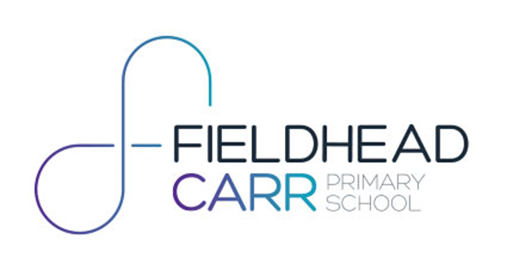
FHC SDP Overview 25-26

Priority 3
Embed:
SEL learning Social Emotional Learning- To develop a shared understanding of SEL across staff, pupils, and families, and establish a common language for talking about emotions, wellbeing, and relationships.

Priority 2
Refine & Resource:

Writing- To embed consistency and raise the quality of teaching and learning in writing by establishing whole-school expectations, strengthening teacher subject knowledge and securing accurate assessment.

ART- review and refine the whole school skills scheme of work for Art and Craft

Priority 1
Implement:
FHC teaching and learning- create a Pedagogical Toolkit of effective teaching strategies to ensure children at Fieldhead Carr know more, do more and remember more

h
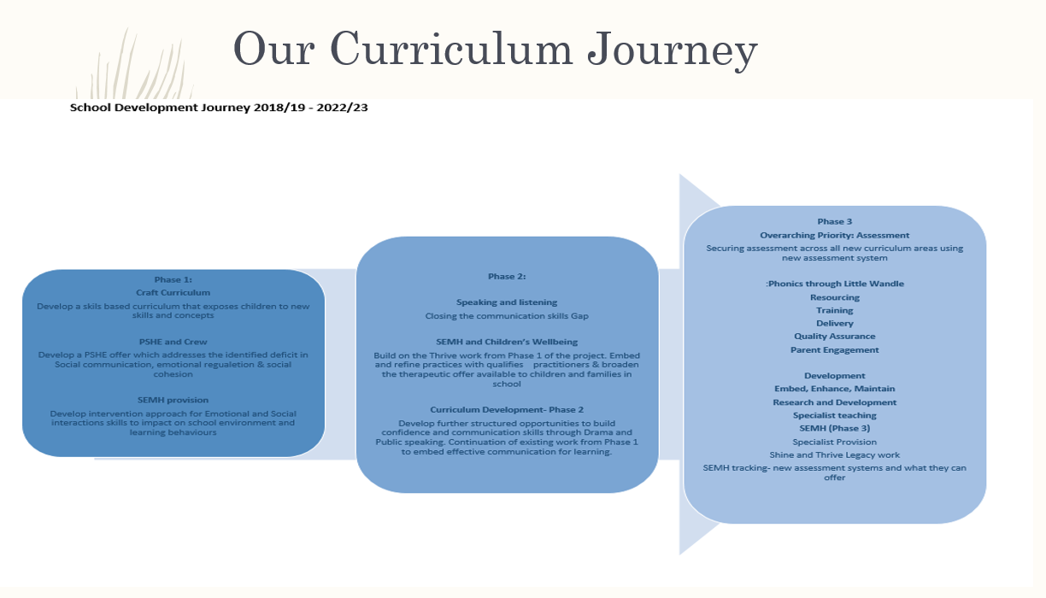
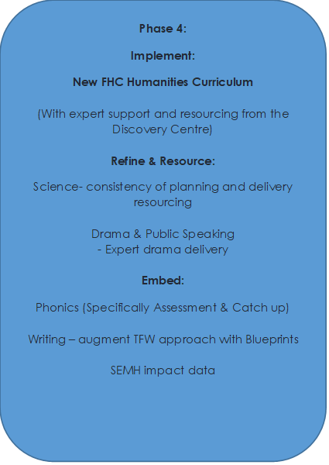
Phase 5:
Implement:
English Writing
To improve attainment in writing across school through curriculum review, subject leader development and a teacher development package for the planning of writing blocks
Refine & Resource:
Geography- new FHC curriculum plan reviewed and refined with support from Discovery Centre Team, Leeds,
Attendance- to increase whole school attendance and reduce number of children who are persistently absence

Embed:
Coaching- effective structure of staff and peer coaching sessions and resourcing to support coaching techniques delivered.
Humanities and Science - consistency of assessment methods including use of entry and exit tasks or assessments (questions and activities based on learning from half-term)

