**Behaviour Policy**

**2024**

**Love to Learn**

A love of learning is instilled in our pupils from a very early age. Fieldhead Carr Primary School is committed to celebrating positive achievements, particularly in relation to self-esteem, positive behaviour and attitudes to learning. Our behaviour practice is underpinned by our PSHE curriculum which teaches our children strategies to develop their emotional and social well-being and develop positive relationships with those around them. We want our children to learn to recognise and regulate their feelings, helping them think before choosing certain types of behaviour. Our aim is to ensure our children are respectful to themselves, each other and the community around them. We want our children to reach their full potential, developing their resilience and leading a safe and responsible lifestyle. Our behaviour practice is adopted by the whole school community to ensure our children are able to learn from positive role models around them. We know that children learn best when they are happy and settled. We ensure that all members of the Fieldhead Carr community follow our school ‘blueprint’ which uses restorative language and positive mantras, highlights praise as a tool for motivation and ensures communication is calm and supportive. We want our children to be motivated to take responsibility for their actions, celebrating the positives and restoratively dealing with mistakes when they happen

**Recommendation**

Governors are requested to read this policy, consider its content and approve its adoption. This policy should be reviewed annually.

|  |  |
| --- | --- |
| Author’s Role | Senior Leadership Team |
| Date | Autumn 2024 |
| Internal Review date | Spring 2025 |
| Review date | As changes |

# Love to Learn

**School Ethos**

We aim to develop positive and meaningful relationships between all members of the school community. When these relationships are developed and deep connections are made, individuals are less likely to cause harm to others or damage other relationships. Our daily crew sessions are used to teach the skills of personal, social and emotional development.

Our behaviour policy recognises the significance of using positive reinforcement and rewards as a motivating tool to enhance children’s learning experiences. We believe that acknowledging and celebrating their efforts and achievements through carefully designed rewards fosters a sense of accomplishment, boosts self-esteem and cultivates a lifelong love for learning. Positive behaviour is consistently reinforced everywhere in school, across the school day – each class follows the behaviour ‘blueprint’ which is displayed in each classroom. The school uses a restorative approach, which links to our PSHE curriculum and Thrive approach. Children are provided with consistent positive encouragement and recognition when they demonstrate positive behaviour. They are supported to make the right choice and learn how to problem solve. Our ‘blueprint’ is taught and embedded across school, from Reception to Year 6. This creates a transparent, whole school theme which everyone strives to work towards.

For occasions when unwanted behaviours arise, we use restorative approaches as outlined in this policy, to help pupils understand the impact of their actions and behaviour. This is done through a structured reactive circle in which we guide and teach the children how to make things right. We use the four zones of regulation to support this as it gives us a foundation for thinking and talking about how we feel. It supports our children in self-regulation and emotional control. The positive behaviour policy operates in conjunction with the following policies:

* + Anti-Bullying
  + Child Protection and Safeguarding
  + KCSIE
  + Care and Control
  + Health and Safety
  + Exclusions
  + Teaching and Learning
  + SEND and Inclusion

## Fieldhead Factors

At Fieldhead Carr, our curriculum allows every child to ‘Love to Learn. Our behaviour ethos is based around six ‘Fieldhead Factors’. Our Factors are based on the principles of the Growth Mindset and underpin everything that we do. We actively encourage all our children to challenge themselves, show resilience and become a positive purple role model to all of our pupils. We believe that everyone’s abilities and talents can be developed through dedication and hard work.

These are outlined below:

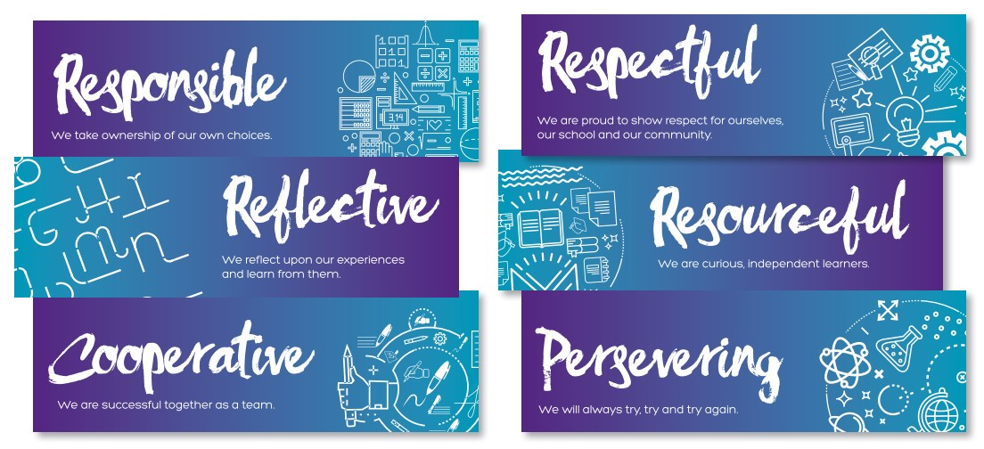

**Respect**

for ourselves, each

other and our future

**Perseverance**

& Courage

–

trying our best,

even when things are

tough

**Reflective and Resourcefu**

l

-

trying to do things for

ourselves and using our

problem solv

i

ng skills to grow

our

independence

**Collaborative Community**

–

working together for everyone’s

benefit

**Responsible**

-

we own our

behaviours

What does this mean in

practice?

In addition to verbal praise and feedback which is embedded in our teaching and learning, we have “whole school” and ‘’class-based’’ incentives to recognise and celebrate good behaviour, good work, helpfulness to peers and adults.

### *Rewarding Positive Learning and Behaviour – Whole School*

## Fieldhead Factors Rewards

Fieldhead Factor trophy is awarded weekly to an individual who has most exemplified the Fieldhead Factors. Teachers can nominate a pupil to the Headteacher if they feel they have earned it through their conduct that week. Parents are invited in to Friday Celebration Assembly to see the presentation. Badges and stickers are available from the Headteacher and Deputy Headteacher, throughout the week for any children who have made a special effort with their learning or behaviour.

**Dojos**

All members of the school community are assigned a class dojo and children are awarded a dojo for following the school rules or achievement towards the Fieldhead Factors. We want all children to enjoy success and derive as much benefit as possible from being at Fieldhead Carr Primary School.



Positive behaviour is rewarded in a range of ways; on an individual basis and as part of a class team. Individually the children are working towards achieving a bronze, silver and gold award for collecting a total of dojos. These awards will be presented and celebrated during our Gold Book assembly.

Examples of dojo rewards:

Holding a door open- 1 responsibility dojo

Helping to tidy up- 1 co-operative dojo

Ready to learn- 1 respectful dojo

Exceptional piece of learning- 2 perseverance dojos

Act of kindness- 2 co-operative dojos

Certificates:

Bronze: 500 Dojos

Silver: 800 Dojos

Gold: 1200 Dojos

Platinum: 1500 Dojos

## Friday Celebration Assembly

Each class teacher selects two pupils from their class who has shown one of the Fieldhead Factors and deserves to have their achievement recognised from that week. The children will receive a celebration certificate and join the other pupils for a breakfast treat. Their parents/carers will be invited to the assembly to hear their special mention.

## Whole School Crew

Every other week we will join together as a school in the hall for a Crew assembly. During these sessions, lead by SLT, we will join together as a community. In each session children have the chance to celebrate, apologise or make a stand about someone or something.

**Special Mention/SLT resilience reward**

If you feel there is a child/ group of children that deserve a ‘Special Mention’ in assembly you can record their achievement to be read out in assembly. SLT will award a resilience badge for children displaying exceptional qualities.

**Positive Purple Raffle**

At the end of each week, teachers will choose all pupils from the class that have represented positive purple (your role models of the week) and regular displayed the 6 Fieldhead factors. These children will be given a raffle ticket (adding their name). It then goes into the class raffle pot. At the end of each half term all raffle tickets are collated together. The raffle for each key stage will be drawn, with winners receiving a variety of prizes such as cinema tickets, crazy golf, sweet treats, water bottles and much more!

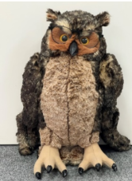

**Attendance**

The Attendance Officer will collate weekly percentages. At the end of each week, the class/es with the highest percentage will receive a certificate and home, ‘Barney’ the attendance owl for the following week.

**Double up praise**

If a child has produced great learning or an ‘exceptional’ fieldhead factor they will be praised by a member of staff. The member of staff then tells another member of staff about this individual. During the school, day both members of staff have praised the pupils, doubling up on the praise.

**Staff kindness cup**

Throughout the week, pupils will enter staff members into the kindness jar. Pupils write the name of the staff member with a reason as to why they’ve been kind towards them. During Friday celebration assembly, the member of staff will be given a shout out and a cup of treats.

### *Rewarding Positive Learning and Behaviour – Class based*

**Class reward system**

This is teacher choice and will be different throughout a key stage. Class reward systems promote positive behaviour and recognition within the classroom and throughout the school day. They are visual and displayed for all to see.

**Friday positive purple text**

Every Friday all pupils who have been entered into the Positive Purple Raffle will receive a text home to congratulate them on their positive attitude to learning and behaviour.

**Calm Area**

Each class has a calm area for any child to access throughout the school day; the space includes a class calm box with resources to support self-regulation when feeling anxious, upset, angry or in need of some time out.

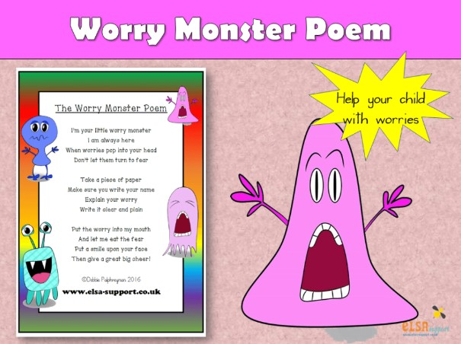

**Worry monster/feelings jar**

In addition to this, each class has a worry monster or worry box. A worry monster is designed to discuss and reduce worries. Children write or draw their worry onto a piece of paper and then feed it to their worry monster. Once the monster has eaten it, the worry can then be discussed and shared with an adult. At the beginning of the school year, each class create their own rules, for example, which adult should check the worry monster and when it should be emptied.

**Individual pupil reward system**

For pupils with SEMH or SEND, we may personalise their rewards to suit the needs of the child. These may come through personalised reward charts (widget to support) that enable the pupil to track their progress through each lesson, morning or day. These systems may include a personalised award that can be delivered within the classroom setting.

**Consistent classroom visuals**

All classroom will have a **widget daily timetable** displayed at the front of the classroom for all pupils to refer to throughout the day. On entering the classroom in a morning and after breaks, pupils will use the **feeling thermometer** to record their feelings. Staff to check in with pupils about how they are feeling. A **noise-o-meter** will be displayed in every classroom to manage the levels of noise. **Visual symbols** are used to communicate needs within the classroom. These are displayed below:

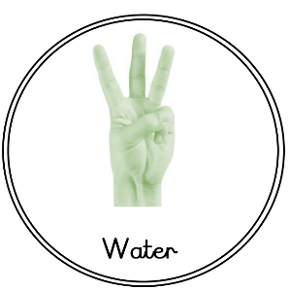

The question/answer symbol will also be used throughout school to gain attention. For example: in the lunch hall the noise level is very loud. A member of staff will hold up their hand using the question/answer sign. Pupils will follow, when all pupils have responded the member of staff will ask a question. Is the noise level appropriate in here?

## Restorative Practice- Dealing with behaviour

When using consequences at Fieldhead Carr Primary School, the child(ren) should always be involved in a restorative conversation and be an active part of deciding upon any consequences. Staff ensure that these conversations are constructive and enable the child to learn from what has happened, as opposed to a sanction being imposed and the child seeing themselves as the victim of a punishment being done ‘to’ them. We aim to help the children look at the harm they have caused to others and see that their sanction is a way of putting things right with the person who has been hurt. Some children with social, emotional or mental health difficulties require time to calm down before this process can begin, this is an important part of developing a child's self-management skills. ‘Time outs’ can be offered to children before an incident is dealt with.

We use consistent language throughout school to deal with any issue or conflict. All members of staff and children know that issues will be dealt with fairly with a ’no blame’ approach. Circles work through the ‘Three Principles of Fair Process’- Restore, Rebuild, Reconnect and the language used is fair, consistent and respectful. It allows for a restorative conversation to take place where each member involved is able to share their opinions and resolve the incident.

**Key Restorative Questions**

• **What happened?**

Drawing out each person’s story one at a time, starting with the person who has caused the harm. The aim is not to come to a definitive conclusion on what has happened, but for each person to have their point of view listened to.

•**Who has been affected?**

Listen to who has been involved.

• **What were you thinking/feeling at the time?**

What each person was thinking and feeling at the time, before and since.

•**Would/could you have done differently?**

Drawn on each person’s thoughts about what they could have done.

•**What do you think needs to happen to make things right?**

How do we agree and negotiate meeting the needs identified above and what support might they need to do this? Staff support pupils in this process but try to ensure the pupils form their own agreement when possible.

The aim here is that the outcome is fair for everyone. If somebody is upset, we aim to make them feel better. If someone has done something wrong, we expect them to be accountable for their own behaviour, take responsibility for their actions and fix the situation by making things right with those who have been affected. This approach encourages those involved to identify ways in which a relationship can be repaired or how they can move forward. By giving pupils this responsibility we are supporting them in developing their own strategies for avoiding and resolving conflict. We also believe that if pupils reach their own agreement as to how to move forward after a conflict, they are more likely to abide by it than if it is suggested by an adult or imposed upon them.

**Whole school stepped sanctions – appendix A**

There may be occasions when children make choices which negatively affect their learning and that of others, or when they don’t behave in the way we all expect. In these cases, it is important that children know that there are clear consequences to their behaviour choices and that all staff will apply these consequences consistently whilst taking into account individual circumstances and needs. We follow a behaviour system called ‘positive purple’ which gives all children the chance to remain in the purple zone, demonstrating the Fieldhead Factors.

Our aim is to repair and rebuild relationships, regulating ourselves and returning to our learning or activity. However, there are times when behaviour leads to a consequence. In some situations, children will be asked to complete learning in their own time, be removed from playtimes/lunchtimes or make an apology for their actions.

In more severe cases, a child may have to repair damaged equipment/environment, complete learning in isolation from their peers or miss school treats/trips with their class. Contact with parents will be made to ensure consistent messages around expectations are shared with the child.

Escalating incidents of behaviour may require the use of personalised reward systems. School and parents will work together to support improvements in behaviour.

**Monitoring of behaviour**

Monitoring the behaviour of children across school is crucial in ensuring school is a safe and conducive learning environment. Staff will use the SEMH flow chart to ensure the correct support for children is received (see appendix B). The monitoring of the flowchart enables early intervention to take place and will signpost to the correct support.

### *Stage 1 monitoring (low level risk)-*

**Class support-** at this stage it is crucial for the classroom team to regularly monitor the behaviours and form an understanding of what is happening. Addressing these behaviours early prevents disruptions and supports the child’s social and emotional development.

* Class teacher monitors the behaviour and ensures incidents are recorded and up to date on CPoMs.
* Regular informal contact is made with parents.
* Personalised positive reinforcements and rewards are created, incorporating the child’s interests
* Any positive handling strategies are shared with all staff

**Inclusion Team support-** will regularly monitor CPoMs to ensure identify patterns of concern

* A class teacher at this stage may request support from the Inclusion Team. This is done through a drop in session (every other Wednesday 3:30-4:30pm). Inclusion Team will offer verbal support and suggestion of strategies.
* An observation will take place

### *Stage 2 monitoring (medium level risk)-*

**Class support-** continues to be the most effective at this stage but requires additional support from the inclusion team

* a PSP (personalised Support Plan) is created which will include targets to develop a child’s SEMHS needs
* Personalised rewards system and parental contact will continue.
* Classroom well-being strategies will continue which may include a designated safe space or work station

**Inclusion Team support**- through consolation with the teacher a bespoke programme will be put into place

* Children formulation forms initial conversations- all members of staff involved with child will attend
* Individual programme delivered by inclusion team this may include intervention around self-esteem, anxiety, social skills etc
* Thrive profile created and sessions to start.
* Parental support offered
* Inclusion team begin to consider external referrals

### *Stage 3 monitoring (high level risk)-*

**Class support-** continues to be the t effective however a high level of external support is required to support the class teacher in meeting the needs of the pupil

* a PSP (personalised Support Plan) continues with termly reviews
* Personalised rewards system and parental contact will continue.
* Classroom well-being strategies will continue which may include a designated safe space or work station
* Recommendations from inclusion team and external professionals built in to daily provision

**Inclusion Team support-**

* Continuation of interventions
* Early Help assessment and intensive family support

**External Professional Support:**

* 1:1 therapeutic sessions
* Family support
* External professional recommendations/ observations/ program of support

### Managing extreme behaviour

Where a child is unable to comply with school policy and difficult situations arise (demonstrating dangerous behaviour) a clear set of procedures should be followed:-

* The child is spoken to calmly and told to follow the member of staff from the classroom. (Clear instructions given/ kinaesthetic prompts/ take-up time/ partial agreement)
* If the child refuses to follow then the class will be removed.
* The child is taken to a quiet space and supported to calm down using agreed strategies.
* When the child is calm and ready to go back to class they may return. The member of staff will stay with that child initially to support their return.
* Team Teach will be used in extreme cases when the child puts themselves or others at risk of harm.

If behaviour is extreme, there may be rare occasions when internal sanctions are not deemed appropriate. In these cases, the HT/DHT has the option to give a child a fixed term suspension. These will be in line with Leeds guidelines, parents/carers will be informed, and the appropriate copies of the paperwork shared with parents and the LA.

**Recording of behaviour**

As outlined above, all staff are expected to follow this policy in regards both rewarding and sanctioning. The use of CPoMs is our online system for reporting persistent behaviour, restorative conversations, Time Out and Time Out+ . Every staff member is expected to report incidents as soon as a possible to ensure they are dealt with effectively. Class teachers should have regular dialogue with parents/ carers when behaviour including low-level disruption is getting in the way of learning. This forms the basis for a collaborative relationship where school and home work together to make improvements and remain consistent.

Incidents of racist, homophobic and hate crimes are dealt with in line with this policy and parental involvement will always be expected to support consequences. These incidents are also reported to the Local Authority. Incidents of bullying are also reported to SLT and the Governors via termly Behaviour Report. Any incidents of online/ cyber bullying (see E-Safety policy) also dealt with in line with this policy.

Incidents of sexualised behaviour – harassment or violence - are reported via CPOMS, which is then always dealt with by a member of SLT and Head Teacher and where necessary DSL (designated safeguarding lead). In the instance of harmful, sexualised behaviours two of our DSL’s will complete an IPRA (individual pupil risk assessment) and the AIM checklist. DSLs will recognise, respond and refer incidents/ pupils to the Local Authority where necessary, following pattern mapping on the AIM checklist. Outcomes and levels of intervention will be determined based upon types of presenting behaviours. Where abusive/ violent behaviours are identified, safety and support planning will be put into place. See both Child Protection and Safeguarding 2023 policy, KCSIE 2023 policy and Anti Bullying policy for school’s responsible curriculum delivery.

**Confiscation of inappropriate items**

What the law allows: There are 2 sets of legal provision which allows staff to confiscate items from pupils:

1. The general power to discipline enables a member of staff to confiscate, retain or dispose of a pupil’s property as a punishment and protects them from liability for damage to, or loss of, any confiscated items. The legislation does not describe what must be done with the confiscated item.

2. Power to search without consent for ‘prohibited items’ including:

* Knives and weapons, Alcohol, Stolen items, Fireworks, Pornographic images, Illegal drugs
* Any article that has been or is likely to be used to commit an offence, cause injury or damage to property.
* Any item banned by the school rules which has been identified in the rules as an item which may be searched for.

3. Weapons and knives and extreme or child pornography must always be handed over to the police.

If and when an item is confiscated from a pupil, an IPRA (pupil risk assessment) may need putting into place for that child to help reduce and control the risk of future incidents.

**Power to discipline beyond the school gate**

Schools have the power to discipline pupils for misbehaving outside of the school premises “to such an extent as is reasonable”. Non-criminal bad behaviour and bullying which occurs off the school premises and which is witnessed by a staff member or reported to the school, may result in a sanction from school at the discretion of SLT/Head teacher. School may discipline pupils for misbehaviour when the pupil is:

• taking part in any school-organised or school-related activity;

• travelling to or from school/ wearing school uniform;

• In some other way identifiable as a pupil at the school;

• could have repercussions for the orderly running of the school;

• poses a threat to another pupil or member of the public;

• could adversely affect the reputation of the school.

In all cases of misbehaviour, the school will only discipline the pupil on school premises or elsewhere when the pupil is under the lawful control of the school.

**Use of reasonable force**

A small minority of pupils might require the use of positive handling techniques in order to ensure their safety, the safety of others, and limit damage to property or to maintain the good order and discipline within the classroom. In such circumstances, the Head teacher or member of staff staff chosen (Team Teach trained) may do this. Following the use of physical intervention, there will be a restorative discussion with any staff and pupils, parent/carers will also be invited to participate. A record of the intervention will be made. Pupils who regularly present challenging physical behaviour will be closely monitored by the inclusion team and SLT. An IPRA (individual pupil risk assessment) which includes a PSP (positive handling plan) will be put into place for these children to help reduce the need for physical intervention and use of reasonable force.

|  |  |  |  |
| --- | --- | --- | --- |
|  | | | |
| **Steps** | **Action** | | **Script** |
| **Step 1:**  **Check in** | (Purpose to identify any reason the child is not able to do...) At the child’s level, to the side, warm tone (privately to be heard by the child)  Aim is to solve any problem together if necessary, so the child can succeed independently. | | I’ve noticed that … / you seem to be in the … zone, is everything ok?  Do you… (understand what you’re doing)? |
| **Step 2:**  **Reminder** | A clear verbal caution delivered privately and calmly. Make the learner aware of their behaviour and expectation. State the behaviour you want to see. | | I’ve noticed you are not following our rule of being… I need you to…I know you can do this; be the best you can be. Thank you for… |
| **Step 3:**  **Cool down** | Continue speaking to the learner privately, calmly with a gentle approach, side on at eye level or lower – non-threatening.  Move to calm area in class to complete learning or take 5.  State the behaviour you need to see and clearly outline the consequences if they continue. | | You have been spoken to already in this session, I need you to … if you don’t… you will be sent to another class (or must finish it at playtime). This is your final reminder in class. You can do this. |
|  | **Resolved**  Continue speaking to the learner privately, calmly with a gentle approach. The child returns to learning and continues in a positive manner. | | Thank you for…  Well done… for…  I really like the way… |
| **Step 4:**  **Time out**  **(in phase)** | **In Class/School**  At this point the learner will have time out in a designated class (within the phase), unless a positive handling plan specifies something different.  - 5 min timer for EYFS/KS1.  - 10 min timer for KS2.  Designated space such as calm area to be used.  After designated time pupil to return to back to class.Continue speaking to the learner privately, calmly with a gentle approach. The child returns to learning and continues in a positive manner. | | When the child is asked to leave the room: I’ve already given you your final reminder, I now need you to go…Please take you book/work with you.  The aim is to repair and rebuild relationships.  Thank you for…  Well done… for…  I really like the way…  Fabulous you’re back! |
| **Step 5:**  **Time out +**  **(inclusion team)** | **This only applies if either:**  *a. The learner refuses to engage with an internal referral and / or the unwanted behaviours persist*  *b. or/ violence and dangerous behaviour is committed.* | | |
| The member of inclusion team must be called to collect the learner in class time. (Call the inclusion office on classroom phone). The teacher should provide work. The teacher must log the incident on CPOMS as soon as possible. A restorative conversation between the child and the adult initially involved must take place. If the incident only involves children, inclusion team to lead this restorative process. If the incident involved a child not being respectful to a member of staff – for example: a TA and a child - the TA would lead the restorative conversation (facilitated by the inclusion team where appropriate), at the end of lesson where possible. Incident to be recorded on CPOMS by the person leading the restorative conversation. | Repair & rebuild relationships.  **Restorative Questions**  What happened?  Who has been affected?  What were you thinking/feeling at the time?  Would/could you have done differently?  What do you think needs to happen to make things right?  Child to suggest consequence (see policy for examples).  **Apology script:**   * I’m sorry for... * It was wrong because… * In future I will…. | |
| **SLT**  **(AHT, DHT, HT)** | **This only applies if:**  An extreme behaviour is committed which may need external sanctions. | | |
| A member of SLT will be called by the inclusion team with the restorative process completed. A member of SLT will speak to those involved and conclude with any appropriate actions. |  | |

|  |  |  |
| --- | --- | --- |
| **FHC Stepped Sanctions – Lunchtime** | | |
| **Steps** | **Action** | **Script** |
| **Praise in public** | A reminder of recognition of the expectations by praising the required behaviour or reminding them of the appropriate rule.  This may also involve a discrete look, involve the staff member moving around the playground, praising someone in the game that is showing the right behaviour. | Thank you for…  Well done… for…  I really like the way… |
| **Step 1:**  **Check in** | (Purpose to identify any reason the child is not able to do...)  At the child’s level, to the side, warm tone (privately to be heard by the child)  Aim is to solve any problem together if necessary, so the child can succeed independently. | I’ve noticed that you are…/in the …zone, is everything OK?  Do you know how to play…?  I’ve noticed you are not following our Fieldhead Factor of being… I need you to… |
| **Step 2:**  **Reminder** | Make the learner aware of their behaviour and which rule they are not following. State the behaviour you want to see, clearly outlining the consequence if they continue. | You have been spoken to already about…I now need you to stand with me so we can talk about what has just happened. EYFS & KS1 – holding the child’s hand.  See restorative conversation below. |
| **Step 3:**  **Cool down** | If the child repeats the behaviour again after already being with you for the restorative conversation, the child will be brought to a bench for 10 minutes (timer to be used).  The person who has witnessed the incident would lead the restorative conversation – this can be facilitated by the inclusion team where appropriate. This will then be logged on CPOMS by the person who dealt with the incident. | The aim is to repair and rebuild relationships.  **Restorative Questions**  What happened?  Who has been affected?  What were you thinking/feeling at the time?  Would/could you have done differently?  What do you think needs to happen to make things right? |
|  | **Resolved**  Continue speaking to the learner privately, calmly with a gentle approach. The child returns to play and continues in a positive manner. | Thank you for…  Well done… for…  I really like the way…  Fabulous you’re back! |
| **Step 4:**  **Time out**  **Inclusion Team or SLT**  **(AHT, DHT, HT)** | **This only applies if either:**  *a. The child refuses to engage / or the unwanted behaviours persist*  *b. or/ violence and dangerous behaviour is committed.* | |
| A child may require time away from the playground, a member of the inclusion team will accompany the child into the building to a calm space outside the AHT/DHT/HT office. A member of the inclusion team will ensure a restorative conversation takes place.  A member of SLT may need to speak to those involved and conclude with any appropriate actions.  If an extreme behaviour has been displayed it may require external sanctions. | The aim is to repair and rebuild relationships. |

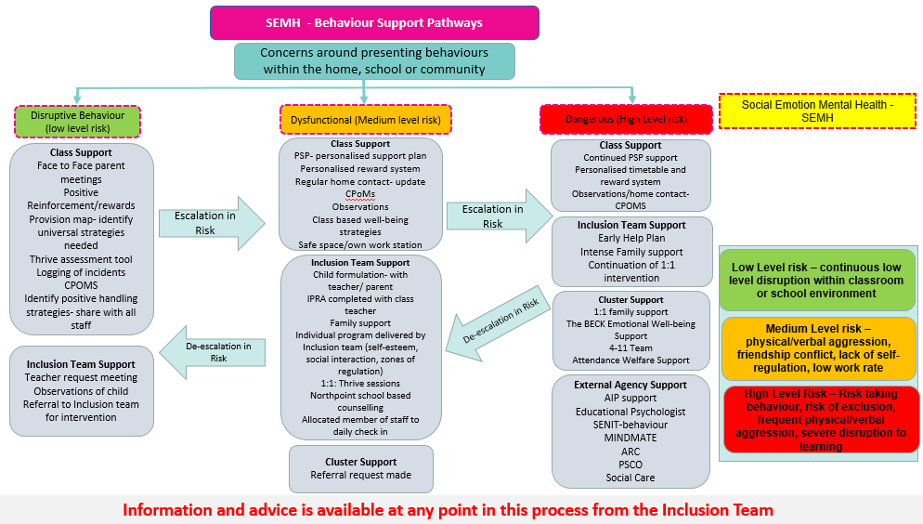**Appendix B**

Appendix C Examples of individual behaviour charts

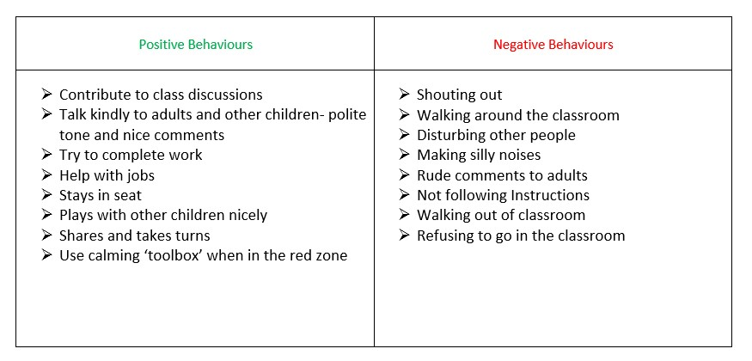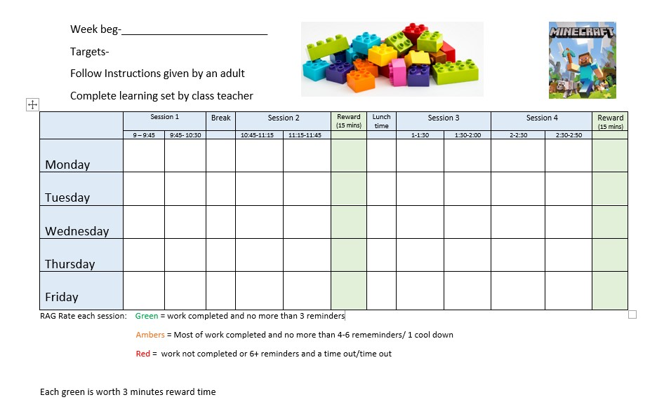

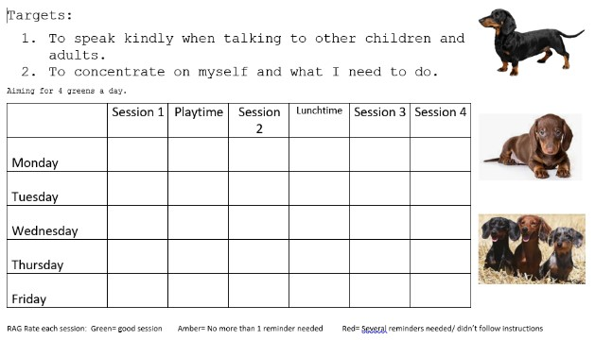

Appendix D- behaviour recording sheets

