**I can say one more than a given number up to 10.**

By the end of this half term, children should be able to say one more than any number up to 10. The aim is for them to say the number that is one more than the number you say to them. They may be able to say what would be one less too.

|  |
| --- |
| Children should see the link that one more than a number is the next number they say when counting.  One more than…  **0 is 1 4 is 5 8 is 9**  **1 is 2 5 is 6 9 is 10**  **2 is 3 6 is 7 10 is 11**  **3 is 4 7 is 8**  Use a number line to hop along one more: |

**Top Tips**

The secret to success is practising **little** and **often**.

* Read Traditional Tales- The Gingerbread Man and The Enormous Turnip.
* Listen to the One More song - <https://www.youtube.com/watch?v=Du6JHupzwVo>
* Use blocks to build a staircase. By adding one block each time it will create a staircase. 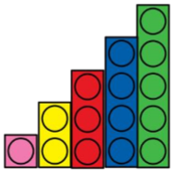

Key Instant Recall Facts

Reception- Spring 1