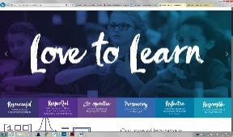

**‘Love to Learn’ at FHC is made up of 6 core values, our ‘Fieldhead Factors’:**

**Our Fieldhead Factors are: Respectful, Responsible, Co-operative, Perseverance, Reflective & Resourceful**

All individual and team behaviour awards are linked to these factors. Children understand the importance of their role in the FHC team and that every member of the team needs to live out the Fieldhead Factors to make our team strong and safe for all.

Our school is an inclusive and diverse Primary School. We have a hidden level of deprivation, complex family situations and a very high level of SEN. We build the importance of individual identity through structured Crew session 12 times a week and through this work children find their place in the community and understand the effort it takes to be a valued part of it.

Many children do not have effective role models for conflict resolution and so Restorative Practice is the basis of all communication in school. Staff and children alike are supported to reflect on their actions, identify the injured party and make amends and then identify protective factors that will stop it happening again. Thrive and Zones of Regulation are used as the mechanism to allow children to learn about their brains and techniques for emotional regulation. Children support each other to make the right choices and over the last 3 years we have built up peer dialogue that supports them in knowing what being ‘one of our team’ looks like. Peer Coaching is a tool used weekly with all levels of staff and children to create supportive networks ensure everyone is seen and supported.

As part of our commitment to developing the ‘whole child’ we offer: Thrive sessions, Anxiety management sessions, Seasons for Growth, Zones of regulation sessions, Talk Therapy, Physical Activity interventions, Personalised Playtimes provision, Speaking and Listening groups, Social engagement groups, Community Projects & individual timetables for those who need them. Our commitment is that every child can find a place in our community and be successful.



Overall Effectiveness

**Good**

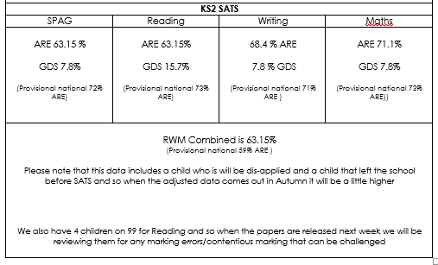

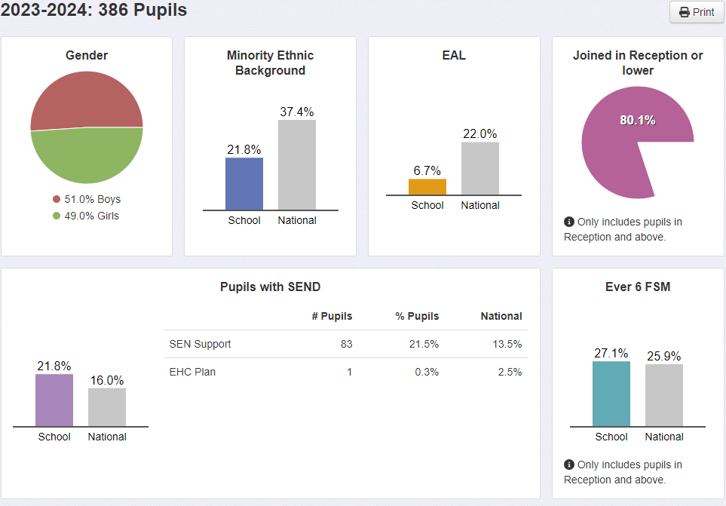

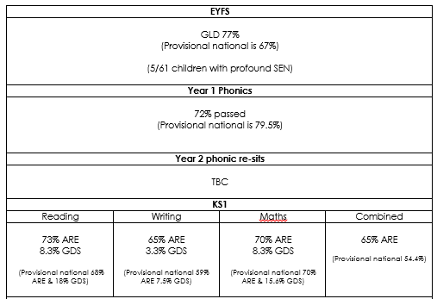

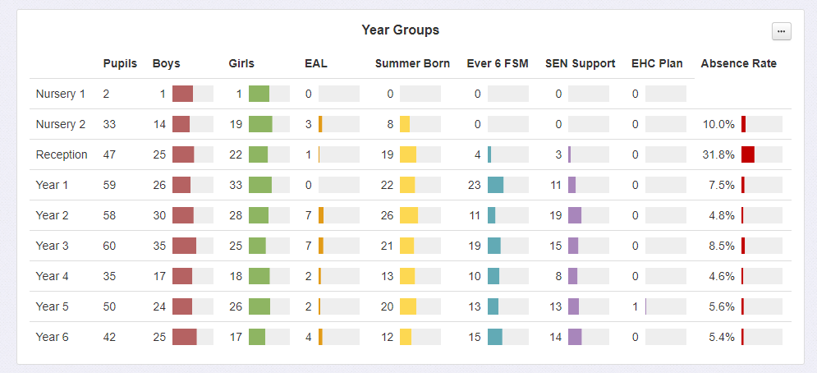

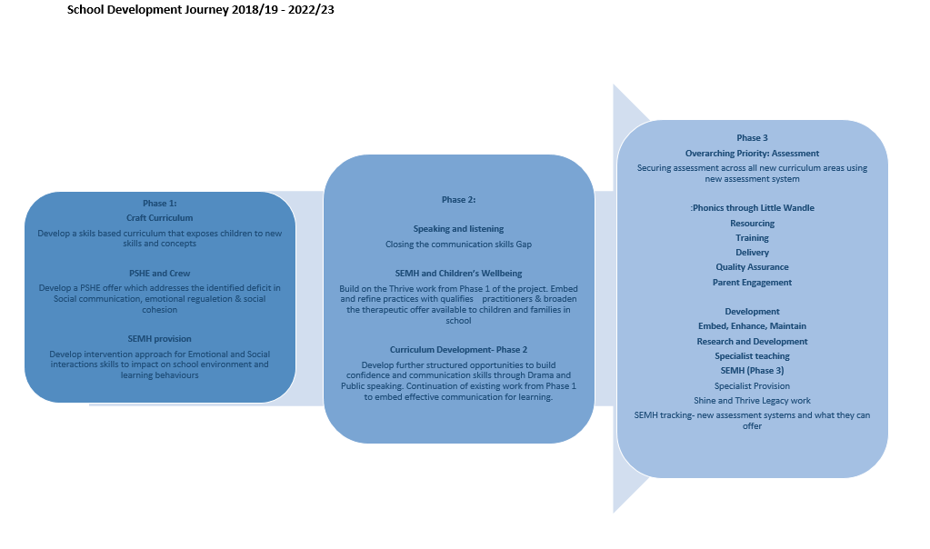

“in Crew we learn about things you should know about when you’re older. Things like life skills. And about little bit how to keep controlled if you’ve lost something or you are upset. We know we can go into a quiet area and get regulated. We’ve got a quiet area in our classroom “

**Pupil voice Spring 23**

‘In Peer coaching you check in with other people that are not in your class. We make sure everyone is OK and talk about how we are managing our feelings. We also talk about the week and what’s been hard and what’s been exciting. I like it because we get to see other children from different classes and make a team that looks out for you!’ **Pupil Voice Spring 23**

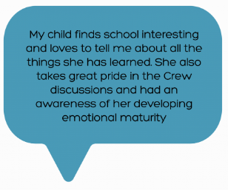

Mathematics is led effectively. The school follows a White Rose mastery approach to the teaching of mathematics. Staff have had extensive professional development, including engaging with the maths hub. They have taken part in and hosted professional practice visits with other schools. The school has introduced Jo Bauler positive norms in a maths classroom which aims to address negative connotations around maths for children and parents. Children are encouraged to view themselves as mathematicians. **(LA School Improvement Advisor visit note autumn 22-23)**

Local Authority SIA feedback- Maths Deep Dive Spr

The curriculum is purposefully planned and sequenced from EYFS upwards

Following our ‘Best Practice’ R&D visit to Treetops Special School in Essex we have profiled children who have barriers to learning that can be addressed with technology and a funding bid to secure provision has been won Summer 23. Provision will be rolled out in Sept 23.

**What is in place that contributes to ‘Good’ Curriculum Development:**

* Curriculum development based in the need presented by children
* Sequential development of different areas of curriculum to target most pressing need and then work outwards- see Curriculum development graphic on pg 2 (23-24 Launch of new Humanities curriculum)
* Curriculum development refined through regular feedback from children and teachers
* Opportunities provided to experience new things and break down fear barriers which stand in the way of cultural growth
* Solid Subject leadership in place- leading development of subject through research, ‘Magpie visits’ and then supporting staff to grown in skill and confidence
* Expert facilitated development of curriculum materials eg: Humanities Curriculum supported by the Discovery Centre & Leeds Trinity University
* Families involved in curriculum design to ensure every child sees themselves in the learning
* LLAS Support for Subject leadership to ensure that subject leaders have degree/Masters qualified experts to advise on element of their curriculum
* LLAs Inclusion projects to ensure high quality, research based thought when developing areas of provision such as Inclusion, EAL eg: Race Equity project with Leeds Trinity University
* FHC Communication Agenda informed by the OSFTED communication agenda- rolled out to EYFS and then considered for the wider school to ensure consistency of opportunity to apply and develop oracy skills
* Focus on opinion forming and valuing others opinions- opportunity for high quality professional dialogue in staff meeting to refine practice as part of every pilot, implement and refine process
* Life skills modelled to address skills and opportunities gaps- reviewed through visits to Specialist provisions to ensure that as well as a universal offer for children there is a pathway for children with profound SEN that need specific skills teaching to allow them to be successful in the wider world
* School trips linked to the contextual need of the cohort rather than Topics eg: Yr5 2023 trips will focus on non-competitive team building opportunities and Empathy building opportunities
* Visitors and trips subsidised to make them accessible to all and make learning real
* Learning from centres of excellence- EXP, Hilderthorpe Primary School, Treetops, Allerton C of E, Lime Hills, The Nest

**Impact:**

* Feedback from children in last **children’s** **survey** showed a positive feedback across all subjects including Maths and English (See Feedback page on school website)
* Feedback at **Pupil Voice** had strong narrative about children enjoying a wide range of subjects (See Feedback page on school website)
* Feedback from the most recent **Parent Survey** was strong around curriculum. This has been further supplemented with parent working groups for curriculum development eg: SEMH working group, Race Equity in curriculum working group. Parents are keen to engage. (See Feedback page on school website)
* **SIA feedback** is consistently strong highlighting a commitment to refining and embedding practice to get the best outcomes for children (See SIA NOVAC forms)
* Engagement of parents in learning improvement on home learning has refined the offer of homework and feedback has been positive (sampled at parents evening Spring 23)
* Quality of work produced - this year we are looking for external exhibition spaces
* **Pupil Voice-** Connor Yr4 (explaining a resolution to a problem to a child new to school) ‘that’s not how we do it here. We are honest and we own our behaviour, so like I pushed you- I just tell miss and then I decide how I could make it right- you’ll get used to it. Have a go!’
* **Internal Transfer children- new to school-**41 of children that have arrived during the last 3 academic years have been labelled as ‘difficult’ in hand over from the home school. They are now on track and making progress
* Improvement in communication skills: pupil voice meetings, feedback from visitors all highlight that children in our school are confident to talk to adults, speak with good levels of detail and articulate effectively. They also highlight a strong focus on manners and moral behaviour.
* **Children’s attitudes** to trying new things – no refusals for any of the new elements of curriculum- specialist Dance, Drama, Public speaking, Peer Coaching, Forest Schools, elements of Craft curriculum. Children are supported to articulate their concerns and staff work with children to profile what might help them to be brave and try something new.

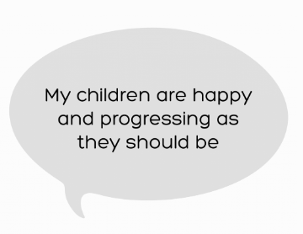

**Local Authority School Improvement Office visit (Spring 23)**

There was effective deployment of adults, both support staff and teachers worked with those who found it most challenging and broke down the learning into smaller steps

**Pupil Voice Q- What is the best thing about FHC?**

Teachers are Awesome & Friendly. Maths, learning lots of new things, seeing friends & taking care of them. English, Science & crafts

**Pupil Voice Q- Would you recommend this school to a friend if they wanted to change schools? why?**

100% of children said yes

Nice friendly kind teachers and pupils, good help with learning, good decorations, fun lessons, get more educated because we learn crafts too. Good school, fun learning lots of kind people. We are a team! Teachers kind & helpful with learning,

**Parent Survey q- would you recommend this school to a friend?**

90% of parents said yes

It’s an amazing school, staffed by a team that genuinely understand the challenges faced by individual learners. There is a consistent focus on improving the learner.

The school is not only about the curriculum in fact that’s just a small part of this school. They focus on happy, healthy children, the support they give their families I would say is unmatched at any Leeds school.

**Parent Survey q- The school values children as individuals?** 92% yes

My son in nursery has autism and they have helped him be more social towards the other children and even help him start talking

Each child is treated as an individual and encouraged to be the best version of themselves.

**What is in place that contributes to ‘Good’ Quality of Education:**

* Progression of skills documents in place for all subjects Nursery-Yr6
* Curriculum and planning guide in place for all staff and used as the basis for September training day annually- contributed to and refined annually by all subject leaders
* CPD in school is tailored to use staff strengths and close staff gaps- we identify teachers with best practice for different skills/subjects and use them for upskilling their peers through Peer Observations
* Refinement of SEN assessment and signposting- SEN is now accurately represented in school data and provision has been tailored to begin to remove all barriers to learning following R&D visit to Treetops Special School Essex
* Wellbeing plan- details provision for children, staff and families and is reviewed with governors annually to ensure need is being met
* Behaviour- Restorative Practice embedded as school based approach to behaviour management
* Expert advice for EYFS development- EYFS advisor has run the EYFS development program in 21-22 (we are now in the monitoring for embedding stage 22-23)
* In 22-23 teaching and support staff have received CPD from an expert in Maths, Writing, Thrive, Drama, Coaching and Art (each year the program is tailored to meet need of the staff cohort)
* Use of experts as teachers in Craft, History, Science & Drama- Visitors with specialist skills used to enrich elements of the curriculum outside of the usual skill expected for a Primary School Teacher
* Specialist Teaching in Forest School, PE, Drama, Dance and Art – to ensure children get a rich experience of these subjects and give teachers scope to focus on high quality delivery of the remaining subjects
* Provision in Yr1-3 to embed enquiring approach to learning and close early childhood gaps around social engagement and play
* Little Wandle Synthetic Phonics program embedded
* Teacher led interventions for academic gap closing
* Lexia and TTR in place for supporting independent learning and closing learning gaps
* COVID Recovery plan- Education Endowment Foundation research linked

**Impact:**

* **KS2 data** is competitive accords schools with similar contexts. We have also address the data blip and the data has been around or above national for the last 4 years.
* Impact of interventions in KS2 SATS- I**nternal Data** shows impact of quality first teaching & intervention on closing the gap from baseline assessments to end of year assessments.
* Impact of crew on learning behaviours and communication are visible in **Parent Surveys, Children’s Surveys and Feedback from visitors.** Children articulate their thoughts with a good level of detail. They show reasoning skills when formulating a response & speak with a listener in mind. They are also developing tolerance and understanding of difference.
* Anecdotal feedback on confidence levels
* SEN assessment- show that specialised provision for individual children is allowing them to make progress. **Feedback from outside agencies consistently** identifies FHC as a centre for good practice and engages more readily with us as a result
* Impact of new Phonics scheme from Autumn data
* Anecdotal impact of TTR and Lexia in children engagement in learning they find hard
* **LA SIA visit feedback report Summer 23**- ‘Lessons start with flashbacks to revisit and consolidate prior learning. This is embedded into the lesson structure and pupils have plentiful opportunities to recap prior learning and address misconceptions.’
* **Feedback from Spring ‘Deputy Head Catalyst Program’ School visit:** (Deputy Heads on the program visit all schools and undertake lesson drop in’s and give feedback) ‘You could see the impact of Crew on the skill and confidence of children’s communication- my Year 6 class wouldn’t be able to talk like that and they have a better starting point in life- Michael Allerton C of E Primary School
* **Feedback from Recent Spring 23 lesson drop ins:** ‘teachers explicitly modelled strategies. Misconceptions were identified and addressed. There was a strong use of mathematical language by staff and children. Sentence stems were modelled and encourages with children asked to explain 'how do you know' and 'why'. Lessons were well paced and expectations for the amount of work that pupils would complete were high.
* **Feedback from Lesson drop in’s with Vicky Bluck**- Literacy Advisor ‘There were lovely examples of how to support learning across school – Lit Team have collated good models for whole school reference.
* **Feedback from LA SIA- May 22**: The comprehensive planning guide provides support for staff to embed a consistent journey of expectation for pupils as they move through the school. In all subjects the knowledge and skills are carefully planned with additional advice about pedagogical content knowledge.

**Staff survey-**95.3% of staff agree that Leadership is active in developing and supporting staff to manage wellbeing and workload

Parental engagement is growing with 280 people visiting during the recent FAB Friday (LA SIA visit report 22-23)

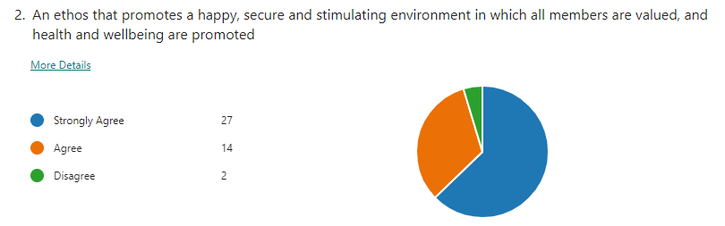

**Staff Survey Q:**

Amazing leadership at FHC. I have worked in many schools across the midlands/Yorkshire but never have I ever had such an amazing and supportive SLT. I love coming to work each day to work with people that value me as a teacher and also take mental health into consideration. Well done to all the leadership team for keeping FHC an amazing place for both teachers and children to teach and learn!

**Peer Coaching Survey Q: give feedback on the impact of Peer Coaching on your wellbeing at work**

82% it has impacted significantly on their wellbeing at work

It starts me off with a positive mind-set. It gives me confidence. It makes you feel connected and looked out for. It helps me keep perspective and focus on solutions. It gives me a support system for any worries or concerns I have. It helps me learn from others.it has built good relationships in our group. I feel safe and supported in my work

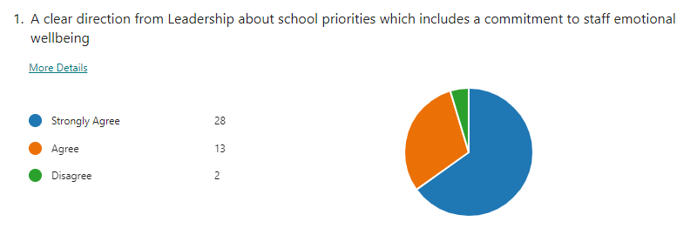

What is in place that contributes to ‘Good’ Leadership and Management:

* Vision and direction is shared clearly and regularly
* Staff training for language and interaction linked to school vision and ethos
* High quality training for Leadership- EW, Headspace, coaching JM- DHT Catalyst Program, RT- DLP Middle leaders- JG-NPQELL, TA & JG- NPQEL
* Performance management for every member of the school team- linked to personalised training profiles and budget
* Delegated leadership structure- SLT and MLT- Clear sharing of delegated leadership plan with all staff
* Subject leader teams for Maths and Literacy
* Subject leaders action plans tied into the SDP priorities
* Financial planning linked to SDP priorities
* Headteacher has strong professional networks: Bluesky Network & LLAS
* Professional networks for Pastoral team though LLAS
* Culture of openness and trust at FHC Open door policy Kind accountability
* Professional Supervision for HT, DHT, DDSL/PM
* Professional team supervision for Yr1 team- holding the highest SEN and Wellbeing need
* Professional training in coaching networks for Support staff team- 1 yr project
* Peer coaching practice in place for all staff and children
* Time given to subject leaders to plan and deliver on their actions
* We nurture staff, invest in staff training and grow our own talent (working with Exceed and York St Johns)
* All SDP priorities have an R&D and testing phase to ensure best possible fit for our children before full roll out
* Curriculum development is a journey shared by all- we do not stop and start things- this helps deepen staff

Skill and confidence in delivery

**Impact:**

* **Good staff retention**- over the last 4 years staff have left for promotion or house moves/family circumstance
* **Staff can identify their personal next steps and give a progress update:** solid record/review in place
* Feedback from families about approachability of staff is very strong
* Honest professional dialogue between peers is supported and used for empowering staff to solve problems
* Goals are measurable and delivered in a timely fashions
* Subject development is steady and effective
* Change in subject practice is measured and reported on
* Governors are given regular and effective feedback on all areas of school life
* **LA SIA visit May 22-** The comprehensive planning guide provides support for staff to embed a consistent journey

of expectation for pupils as they move through the school. In all subjects the knowledge and skills are carefully

planned with additional advice about pedagogical content knowledge.

* **LA SIA visit May 22-**Despite the challenges of the pandemic the Head and Deputy have worked tirelessly to

transform the culture of the school. They have successfully brought staff with them and so staff retention has

been high. Individual teachers have been supported to improve their practice and to become consistently

stronger teachers. The impact of their work was highly visible as the ASIA visited the school for the first time since the

start of the pandemic.

**Attendance :**

Persistent Absence is now broadly back in line with National picture after a 2 year increase during covid

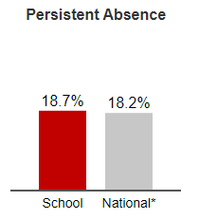

General attendance is also now back in line with National picture after a significant increase during COVID recovery years

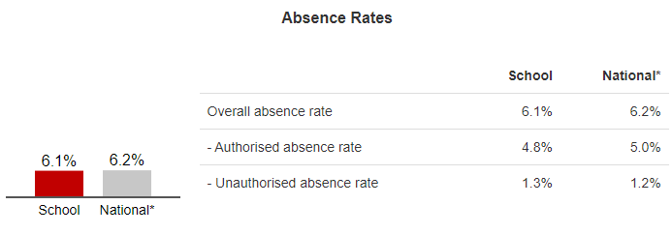

Coordinated strategy with cluster teams has supported a consistent and effective approach to attendance which has supported this improvement overall.

**Peer Coaching Survey Q: What’s working well?**

Children check in with each other throughout the week.

Learn new skills-They help each other with ‘eating their frogs’ and solving their problems

**Peer Coaching Survey Q: give feedback on the impact of peer coaching on your group**

Pupils have started to share a special bond with each other. They show genuine interest in what others are doing and feeling.

**Pupil Voice Q- does your school teach you how to stay safe?**

**100% yes**

**We learn about:** Healthy food, not doing silly things, crossing the road on school trips, don’t run in school, the rules on playground, gates locked, Veg on school menu’s, fruit option, fire alarm, good evacuation. Stay safe passwords. Dangers of internet, vegan food available at lunch. E-Safety safer on line, healthy dining hall posters, health ambassadors, healthy snacks

**Parent Survey- My child is happy at school?** 94% yes

His needs are met, he feels comfortable in his classroom environment and always comes home discussing a wide range of activities he has engaged in.

Child finds school interesting and loves to tell me about all the things she has learned. She also takes great pride in the Crew discussions and had an awareness of her developing emotional maturity.

They are always happy to go in and come out smiling

**Pupil Voice Q- does you school teach you how to be kind and respectful?**

**100% yes**

We learn:

To help when someone hurt, to call people by the right name, crew time, Fieldhead Factors, kindness jar, helps you to work & be kind – dojo’s reward for being kind, being mean = take marbles out of jar, butterfly effect, crew assembly, hands & feet to self, show people round school, be proud of our school team

respect, random act of kindness, cool down areas, sharing

Setting good examples of what kindness looks like

What is in place that contributes to ‘Good’ Behaviours and Attitudes’:

* New Behaviour policy and FHC Blueprint- using restorative practice as the basis for all interactions in school
* Wider experience through curriculum to break down refusal barriers
* Peer Coaching- SLT, Whole Team & Yr1-6 vertical groups
* Crew x 10 weekly
* Whole school crew alternate weeks- Celebrating, apologising and ‘Making a Stand!’
* Public celebration of effort and resilience rather than simply for achievement- Fieldhead Factor Trophy and Celebration Certificates. This process Factors make the factors real by linking them to real life examples in our setting- children are delighted when they win and Parents attend the assembly to share in their success
* Thrive & Zones of Regulation used as the basis of toolkit for children to self-regulate and access support
* Open door opportunities for children to access SLT- children visit on a daily basis and give a running feedback on the life of the school. Many refinements to plans and projects have come through this ongoing dialogue
* Fieldhead Factor Trophy, Headteacher Award and Special Mentions used to publically praise/highlight the behaviours we want in school.
* Children’s teacher nominations weekly- this follows the same format as the ones teachers use for celebration assembly and strengthens a collective narrative that all members of the FHC community are learners (Run weekly by School council)
* Peer Nominations for Gold book in some classes
* School council for children to impact on school- décor, diffusers, reading corners
* No pens learning days & Drop Everything and Read
* Collaborative working & problem solving sessions
* Yr 6 Responsibilities, Fab Friends, Sports Leaders
* Attendance and positive purple
* Engagement with Cluster and AIP for extended services to support children struggling to access their entitlement

**Impact:**

* **Children Self-referrals** for support for both academic and wellbeing issues
* **Review of Summer 23** shows exclusion only for children with extreme SEMH need, waiting for specialist placement
* Impact on attendance management for low attenders is positive with all persistent absentees making progress towards their attendance targets. The use of **fast-track fines** has been implemented using the support of the AIP for those taking unauthorised absence over 5 days
* **Behaviour data** set shows serious behaviour incidents are now minimal, medium level incidents all have parent engagement working towards a resolution & low level behaviour incidents have reduced despite a refinement to the recording which has added more minor issues into the category
* **Impact of Crew- observed in SIA visit May 22-** ‘The school environment was calm and purposeful. Children were observed discussing their behaviours and motivations with their peers. One pupil spoke about how hitting out was no longer his first strategy when faced with a situation he found difficult’
* Comments from parent survey
* SIA visit comments – calm and purposeful
* **Feedback from trips and visits 22-23** all highlighted polite, calm, inquisitive and engaged learners in their feedback to setting
* **Feedback from crew lesson drop in’s Nov 22**- (sample of 8 sets of feedback) Classroom very calm, Transitions calm to and from carpet, Children calm and on task throughout the lesson
* **LA SIA visit Spring 23 visit report:** ‘Lessons were calm and purposeful with positive attitudes to learning seen in all classes. Staff praised positive behaviours and set clear expectations.’
* **Feedback from ‘New Starter Parent visit’ (Autumn 22)-** ‘your children are so polite and your school is really calm. It makes me feel my child would be safe here’
* **Feedback from Parent Survey:**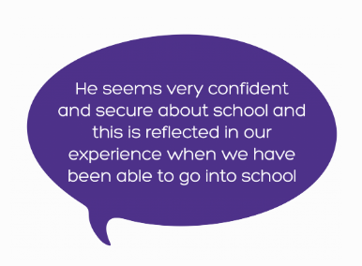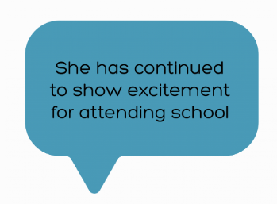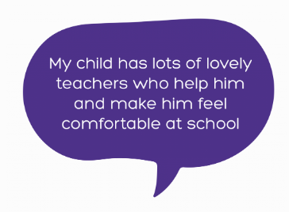

**‘My child came to FHC after refusing school and having an awful experience. Within weeks she was settled and happy here. They just get her. They put time in to make sure they saw her and got to know her, what she likes, what works for her and because of that she has been successful. She is like a different child!’**

**Parent Feedback**

**‘Snapdragons has been a lifeline for my little girl. She has made so much progress’**

**Parent Feedback**



 



What is in place that contributes to ‘Good’ Provision for SEN in our school:

* Cohesive school wide vision for SEN shared by all staff & stakeholders
* Clear and effective partnerships with parents
* Skilled & empathetic staff in key roles for SEN
* FHC Graduated Response in place and shared with staff and parents
* Highly developed Inclusion team provision (5 staff)
* Specialist provision for children unable to access classroom learning (snapdragons)
* Intensive staff training
* SLT support interactions with the Local Authority to ensure processes are timely and effective for children and families (Headteacher sits on 2 forums for the LA working to develop Leeds offer)
* Development of informative practice to ensure all staff working with children can easily access their key information: Pupil Passports, PLP’s, Thrive profiles, Individualised timetables
* Practice informed by experts in specialist provision
* R&D visits to inform choices for products to deliver specific provision ie: dyslexia provision, communication strategies for children with autism, visual communication tools, profiling children for supportive technology
* Research, pilot and implement approach taken to all initiatives linked to SEN
* Strong working relationships with Cluster and AIP (extended services provision)
* EEF research used to inform use of support staff to best meet need on low and medium level need within the classroom

**Impact:**

* **Positive Parent comments from Snapdragons-** without this provision unsure how they would access education, grateful for opportunities that snapdragons have given, progress in communication and vocab at home has improved
* **SEND Termly reviews-**parental uptake is around 90% of all SEND children across school. All parents engage with process of SEN support plans and input into what is working well and what is not.
* **Attainment of SEND cohort-**our curriculum identifies pathways were our SEND cohort can excel e.g. Maths which shows the highest end of year data for our SEND cohort. Through analysis it shows the nature of activities such as practical, visual, process driven and repetitive, are strategies used effectively to allow our children to be successful.
* **Progress Data of children with SEND-** most complex year group 4 have made the most progress across RWM
* **Provision in place through cluster**- cluster have used schools SEMH pathways to share with cluster school as good practice, inclusion team presentation to cluster team around school model of delegated job was highlighted as best practise and used as an example to cluster schools.
* **Provision in place through AIP-**feedback Sept 23, praised the school system for having strong processes internally to support the most vulnerable pupils with SEMHS needs and how support from external agencies is sought when school strategies have been exhausted which allows AIP to be more effective in their role to support schools
* **Thrive provision**- has been used by AIP, cluster and LLA as best practice model for schools setting up this practise in the area
* **Speech and Language support-**Every child with a speech and language plan has to access high quality weekly sessions in school and significant progress towards targets has been noted in SaLT review meeting. Re-referral progress is timely and new targets are provided for those that need
* **Impact of Lexia**- 46 children across school access Lexia, supported parents in accessing intervention at home and feel able to support intervention
* **Targeted working with extended services-**3 children have successfully been placed in specialist provision with a further 6 being supported through the same process for a transition to specialist between Sept 24 and 25. Provision in school whilst they await placement has been judged as exemplary by AIP, Cluster, Leeds H&S,SENIT

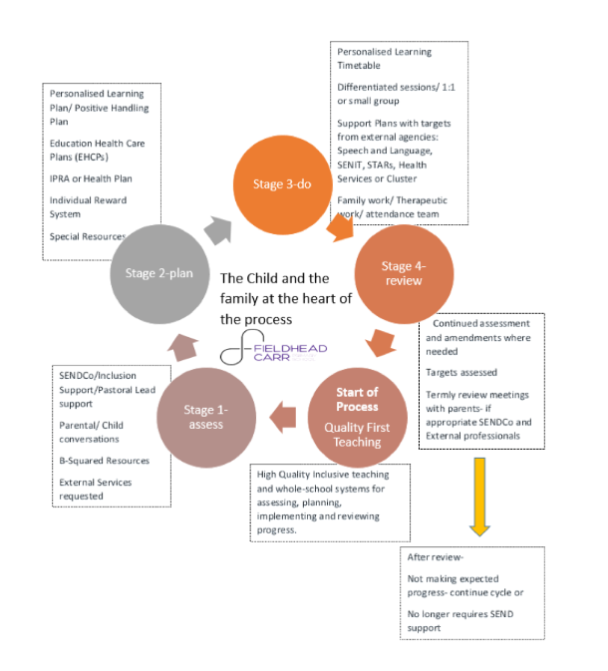

* **Feedback from parents around support for children transitioning to specialist secondary-**local authority unable to place children, SEND team through formal complaint procedures were able to secure places for both pupils
* **Feedback from parents around support for children awaiting EHCP assessment-**8 children awaiting completion of EHCPs which now fall short of the statutory timescales have been supported to access the complaints process which has impacted on timely movement to ensure the provision around the children is correct