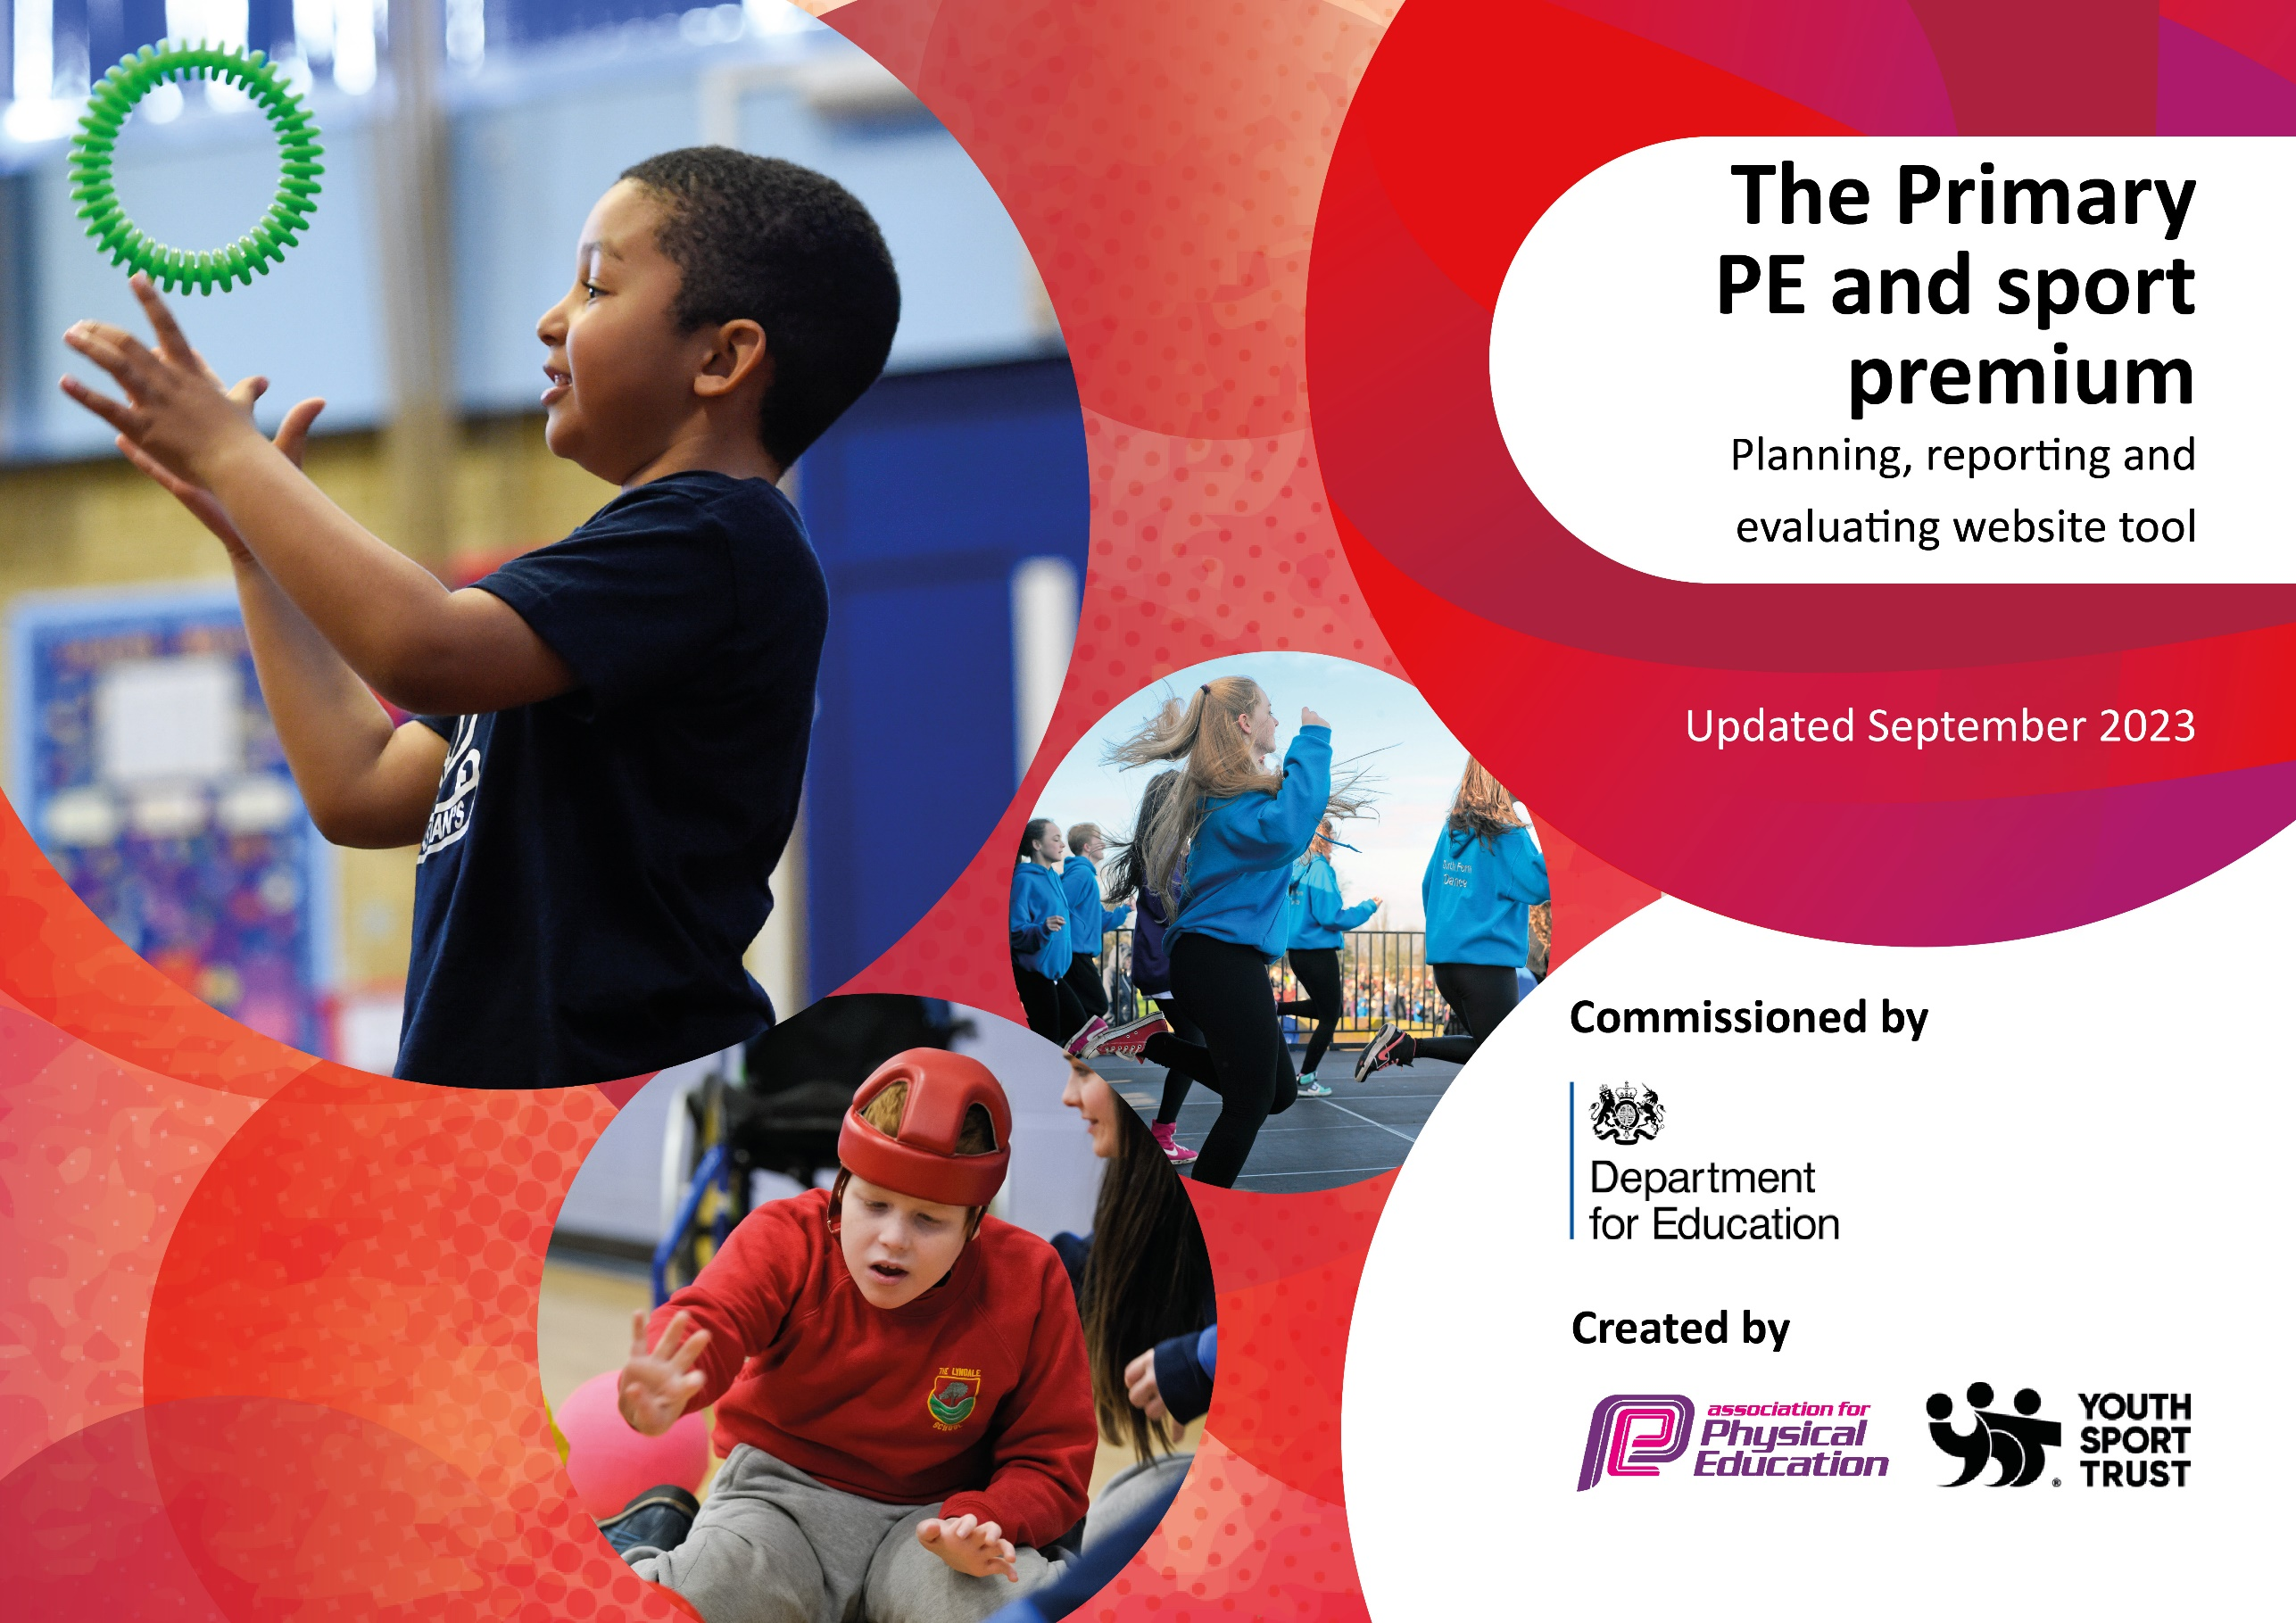

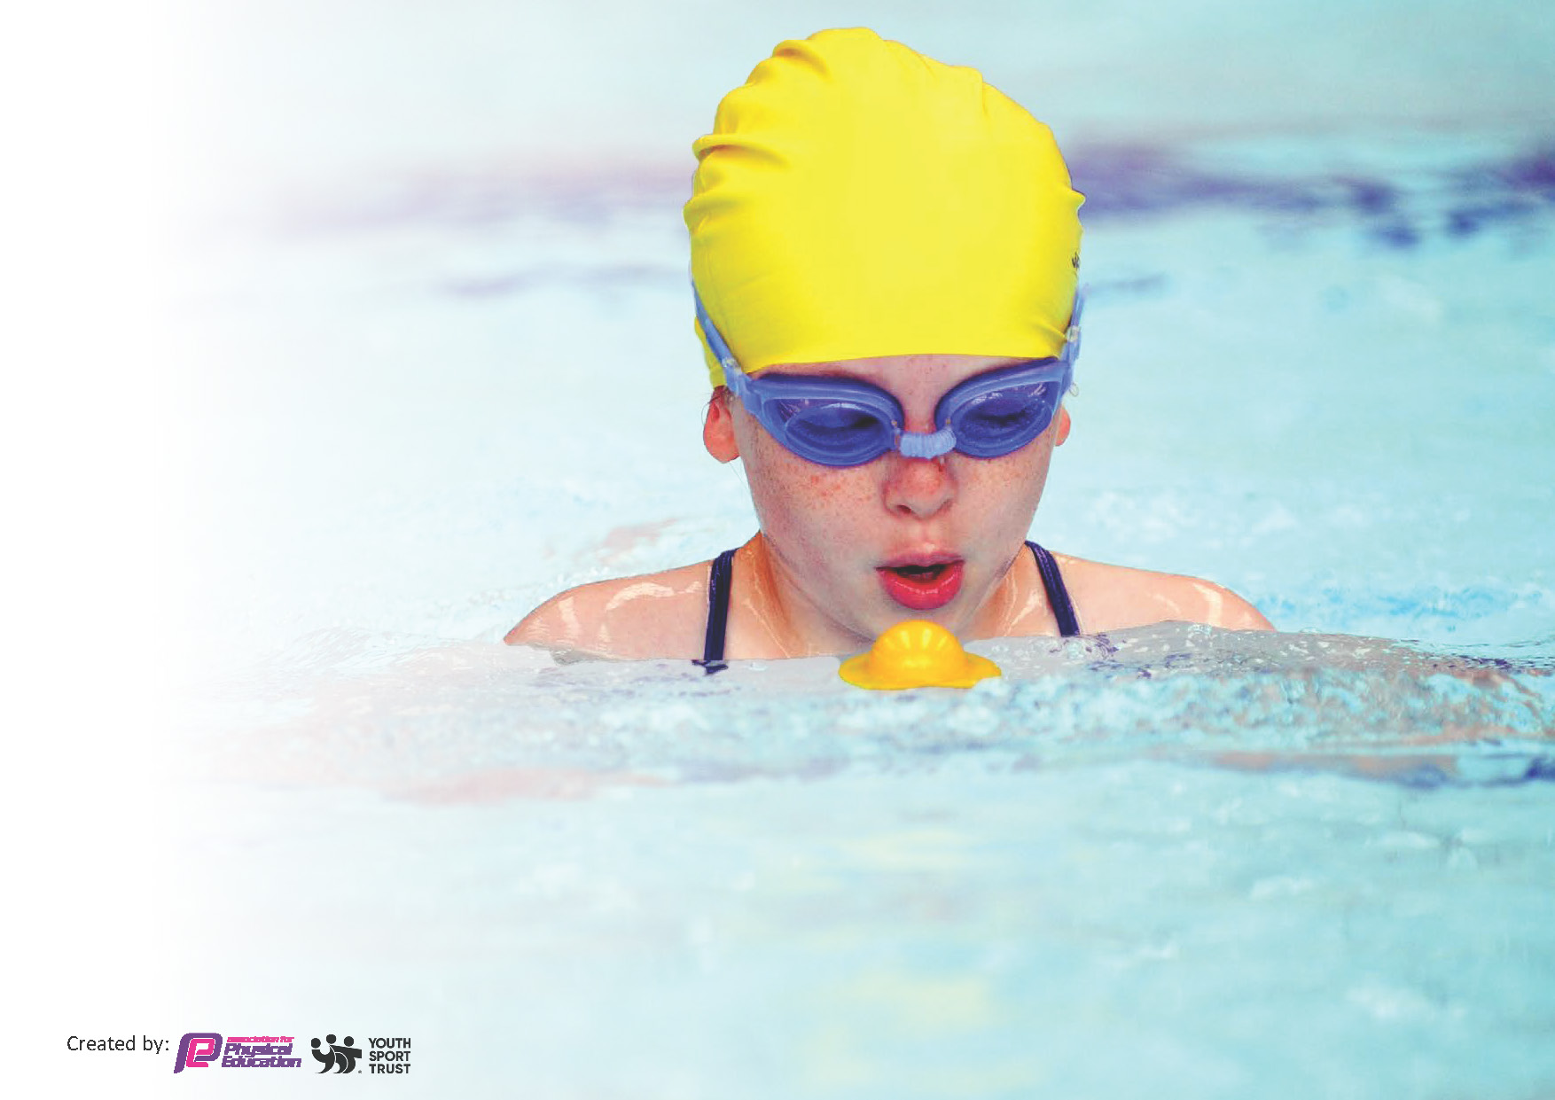
This template can be used for multiple purposes:
by:
- It enables schools to effectively plan their use of the Primary PE and sport premium
- It helps schools to meet the requirements (as set out in guidance) to publish information on their Primary PE and sport premium
- It will be an effective document to support Ofsted inspections enabling schools to evidence progress in Physical Education (PE) and evidence swimming attainment, which forms part of the PE National Curriculum. We would recommend schools consider
the Intent, Implementation and Impact of any spend, as examined within the Education Inspection Framework.

It is important that your grant is used effectively and based on school need.

Schools must use the funding to make additional and sustainable
improvements to the quality of the PE, School Sport and Physical Activity (PESSPA)
they offer. This means that you should use the Primary PE and sport premium to:

- Build capacity and capability within the school to ensure that improvements made now will benefit pupils joining the school in future years
- Develop or add to the PESSPA activities that your school already offers.

The Primary PE and sport premium should not be used to fund capital spend projects; the school’s core budget should fund these. Further detail on capital expenditure can be found in the updated Primary PE and sport premium guidance.

The Primary PE and sport premium guidance, outlines 5 key priorities that funding should be used towards. It is not

necessary that spending has to meet all the key priorities, you should select the priorities that you aim to use any funding towards.

Although completing this template is not a requirement for schools, schools are required to publish details of how they spend this funding. Schools must also outline what the impact this funding has had on pupils’ PE and sport participation and attainment and how any spending will be sustainable in the future. All funding must be spent by 31st July 2024.

The Department for Education has worked closely with the Association for Physical Education (afPE) and the Youth Sport Trust (YST) to develop this template and encourages schools to use it. This template is an effective way of meeting the reporting requirements of the Primary PE and sport premium.
Review of last year’s spend and key achievements (2022/2023)

We recommend you start by reflecting on the impact of current provision and reviewing your previous spend.

Activity/Action | Impact | Comments
- Full-time dance teacher employed  - Weekly small group physical interventions lead by Jake & Jam  - Bikeability team to come in and deliver bike safety sessions  - Sports competitions hosted at FHC  - Interschool competitions at local schools  - High quality PE lessons lead by full-time PE teacher  - After school sports clubs for children 3x a week  - Lunchtime clubs  - Sports Leader role for children at lunchtime  - Lunchtime sports coaching sessions | - Children engaging in sport they might not usually have access to  - Children having access to extra physical development  - Increased participation from both male and female children of all ages  - Decrease of behavioral incidents at break and lunch times  - Children more focused and engaged  - The profile of sport being raised across school  - Sport benefiting children’s mental health as well as physical development  - Enhanced opportunities for children to take part in inter-school competitions and intra-school competitions | - Sport being spoken about in school as something positive that the children enjoy  - Children are more engaged in lessons  - Larger uptake of children wanting to access after school sports clubs and clubs outside of school  - Pupil voice  - Year 6 pupil: “Mr. McManus has shown us that PE isn’t just about being good at sport. It helps us with our mental health and creates new friendships.”  - Less behavioral incidents during PE  - Children eager to learn new skills and find out what lesson they will be doing  - Less lunchtime behavioral incidents

Key priorities and Planning
This planning template will allow schools to accurately plan their spending.

Action – what are you planning to do | Who does this action impact? | Key indicator to meet | Impacts and how sustainability will be achieved? | Cost linked to the action
- Clubs on offer after school (3 days a week) to children of all abilities and ages.  - Lunch time playground rota introduced to give children an equal chance and opportunity to use different sporting areas within school  - Research physical activity programmes and interventions including Active Learning and 10 minute activity breaks.  - New lunchtime equipment purchased for children to use  - Purchase new PE scheme of work  - Organise school sports competitions throughout the calendar year  - Full-time PE teacher employed by FHC  - 0.4 dance teacher employed by FHC  - Jake and Jam physical intervention group work  - Bike Ability sessions  - Balance Bike sessions  - Five Star Sports sessions during sports week  - Purchase of new PE equipment  - Year 5 Swimming at John Smeaton | - PE teacher who will lead the extra sessions  - Children of all ages who will take part in the extra sessions  - Lunchtime staff who will need to be aware of the rota for children and take part in CPD training throughout the year  - Children of KS1 and KS2 who will need to be aware of the rota  - Teachers and teaching assistants.  - Children of all ages  - Children will be more engaged during lesson time  - Lunchtime staff who need to be aware of where equipment is used and how to help children use it  - KS1 and KS2 children  - Teachers and children who will now have access to consistent high-quality planning  - PE Lead and children who will have access to more opportunities to take part in sport outside of school  - Teachers, TA’s and children. Consistent and high quality PE lessons for children of all ages to take part in.  - Children of KS1 and KS2 who will be given opportunities to take part in high-quality dance sessions  - Children of KS1 and KS2 given extra time outside of their usual PE lesson to develop physical, social and cognitive skills  - Children of all ages who will be given the opportunity to access something they might have limited access to outside of school  - Children of all ages given the opportunity to take part in niche sports that they might usually have limited access to  - Children of all ages who will take part in high quality PE lessons using equipment suitable for their age and ability  - Children of upper KS2 who will take part in the swimming sessions | - Key indicator 4: Broader experience of a range of sports and activities offered to all pupils.  - Key indicator 2 -The engagement of all pupils in regular physical activity – the Chief Medical Officer guidelines recommend that all children and young people aged 5 to 18 engage in at least 60 minutes of physical activity per day, of which 30 minutes should be in school.  - Key indicator 4: Broader experience of a range of sports and activities offered to all pupils.  - Key indicator 3: Profile of PE and sport is raised across the school as a tool for whole school improvement  - Key indicator 2 -The engagement of all pupils in regular physical activity – the Chief Medical Officer guidelines recommend that all children and young people aged 5 to 18 engage in at least 60 minutes of physical activity per day, of which 30 minutes should be in school.  - Key indicator 2 -The engagement of all pupils in regular physical activity – the Chief Medical Officer guidelines recommend that all children and young people aged 5 to 18 engage in at least 60 minutes of physical activity per day, of which 30 minutes should be in school.  - Key indicator 4: Broader experience of a range of sports and activities offered to all pupils.  - Key Indicator 1: Increased confidence, knowledge, and skills of all staff in teaching PE and sport.  - Key indicator 5: Increased participation in competitive sport.  - Key indicator 2 -The engagement of all pupils in regular physical activity – the Chief Medical Officer guidelines recommend that all children and young people aged 5 to 18 engage in at least 60 minutes of physical activity per day, of which 30 minutes should be in school.  - Key indicator 4: Broader experience of a range of sports and activities offered to all pupils.  - Key Indicator 1: Increased confidence, knowledge, and skills of all staff in teaching PE and sport.  - Key indicator 2 -The engagement of all pupils in regular physical activity – the Chief Medical Officer guidelines recommend that all children and young people aged 5 to 18 engage in at least 60 minutes of physical activity per day, of which 30 minutes should be in school.  - Key indicator 3: Profile of PE and sport is raised across the school as a tool for whole school improvement  - Key indicator 2 -The engagement of all pupils in regular physical activity – the Chief Medical Officer guidelines recommend that all children and young people aged 5 to 18 engage in at least 60 minutes of physical activity per day, of which 30 minutes should be in school.  - Key indicator 4: Broader experience of a range of sports and activities offered to all pupils.  - Key indicator 2 -The engagement of all pupils in regular physical activity – the Chief Medical Officer guidelines recommend that all children and young people aged 5 to 18 engage in at least 60 minutes of physical activity per day, of which 30 minutes should be in school.  - Key indicator 4: Broader experience of a range of sports and activities offered to all pupils.  - Key indicator 4: Broader experience of a range of sports and activities offered to all pupils.  - Key indicator 2 -The engagement of all pupils in regular physical activity – the Chief Medical Officer guidelines recommend that all children and young people aged 5 to 18 engage in at least 60 minutes of physical activity per day, of which 30 minutes should be in school.  - Key indicator 4: Broader experience of a range of sports and activities offered to all pupils. | - Increased participation from both male and female children of all ages  - Sustainability will come from parent voice and increased promotion of clubs within school  - Decrease of behavioural incidents at break and lunch times  - Sustainability will come from review of rota and ensuring sport/activities stay relevant  - Children more focused and engaged  - Review of physical intervention programmes to ensure they are meeting pupil needs  - Daily Mile introduced. Teachers reporting that children are more focused and alert during lessons  - Regular meetings with teachers for updates  - Children questionnaire to find out what areas of the playground they want to improve and areas they are currently enjoying  - Ensuring lunchtime equipment is looked after and making sure any lost/old equipment is replaced  - Children of all ages will have access to consistent PE lessons that are planned to meet the needs of their particular year group  - Regular review of lessons and PEPlanning.org lesson plans  - Sustainability kept by Keeping good relationships with local schools/PE leads  - Ensuring children voice what competitions they would like to take part in  - Review of competitions and how successful they were  - Children will be taught by the same PE teacher each week. Allows them to build their relationship with PE as a subject and will help them feel more comfortable when being taught any topics of PE they don’t feel comfortable with  - Annual review of lesson plans. What worked well, what didn’t?  - Children are being given the opportunity to access a sport that may be of limited access outside of school  - Termly meetings with Steph (dance teacher) to discuss how sessions are going  - Small group work will allow some children to improve their gross motor skills and gain extra confidence  - Regular meetings to discuss pupil progress and pupil needs  - Bike Ability will allow children to gain knowledge about safety outside of school when riding a bike  - Balance Bike sessions will allow children of KS1 to access skills that will help them with physical development  - Five Star Sports sessions will give children the chance to gain knowledge of new sports  - Audit of PE equipment at the start and end of each academic year to see what new equipment needs to be purchased  - Review at the end of each academic year on swimming sessions. What is working well, what needs to change etc… | £3744  £1500  £350  £250  £10,000 (p/t)  £10400  £5400  £250  £350  £800

- Intra-school sports day  - Level 5 training for PE Lead  - CPD Training for staff | - All teachers and TA’s  - Children of all ages  - Parents of FHC children  - PE Lead  - All staff members  - PE Lead | - Key indicator 3: Profile of PE and sport is raised across the school as a tool for whole school improvement  - Key indicator 4: Broader experience of a range of sports and activities offered to all pupils.  - Key Indicator 1: Increased confidence, knowledge, and skills of all staff in teaching PE and sport.  - Key Indicator 1: Increased confidence, knowledge, and skills of all staff in teaching PE and sport. | - Review each year of what equipment is needed for the day  - What events worked well, what didn’t…  - Pupil voice  - Will allow PE Lead to lead more CPD training for all of school staff  - Regular meetings with staff to discuss areas they would like to improve in regarding teaching of PE | £300

Key achievements 2023-2024
This template will be completed at the end of the academic year and will showcase the key achievements schools have made with their Primary PE and sport premium spending.

Activity/Action | Impact | Comments

Swimming Data
Meeting National Curriculum requirements for swimming and water safety.
Priority should always be given to ensuring that pupils can perform safe self-rescue even if they do not fully meet the first two requirements of the National Curriculum programme of study

Question | Stats: | Further context  Relative to local challenges
What percentage of your current Year 6 cohort can swim competently, confidently and proficiently over a distance of at least 25 metres? | 52.5%
What percentage of your current Year 6 cohort can use a range of strokes effectively [for example, front crawl, backstroke, and breaststroke]? | 57.5%

What percentage of your current Year 6 cohort are able to perform safe self-rescue in different water-based situations? | 57.5%
If your schools swimming data is below national expectation, you can choose to use the Primary PE and sport premium to provide additional top-up sessions for those pupils that did not meet National Curriculum  requirements after the completion of core lessons. Have you done this? | No
Have you provided CPD to improve the knowledge and confidence of staff to be able to teach swimming and water safety? | No

Signed off by:

Head Teacher: | Emma Wraighte
Subject Leader or the individual responsible for the Primary PE and sport premium: | Luke McManus – PE Lead
Governor: | Linda Provins
Date: | 23/11/23

