Curriculum Intent
The FHC Curriculum- Our Vision in action
The ‘Why?’
Our context is a very mixed one with significant pockets of disadvantage and hidden elements of embedded community complexity. Many of our children begin their learning journey at a disadvantage to their national peer group. Their wider world experiences are fewer and their experience of confident, effective and skilled role models is often also lesser than their peers nationally. In the research and Development phase of our Curriculum pupil feedback suggested that children could not confidently identify their personal traits and skills. There was a ‘give up and get cross’ mentality. Children were not willing to be wrong or to fail. Neither could they see a path into the future for themselves that was purposeful, positive and built on their unique qualities.

Curriculum testing phase
During the Testing Phase of the curriculum we prioritised PSHE, Communication, Public Speaking and Craft. We used (and continue to use) Crew as a vehicle to develop children’s skills in active listening, forming opinions and explaining their thoughts. This has allowed children to see a purpose for their wider learning and has had a huge positive impact on learning behaviours and enthusiasm for learning.

The New FHC curriculum
This full curriculum roll out builds on the work we have done in the testing phase and provides a sequential pathways for children to learn content and skills that will be deeply embedded throughout their 7 years of study and will prepare them to confidently take on the challenge of High school and all its possibilities when the time comes.
The ‘How?’

At FHC our curriculum allows every child to ‘Love to Learn’. The Curriculum at FHC is built on 6 core values and 4 strands of study.

Our Values (Fieldhead Factors)
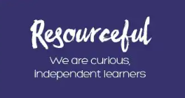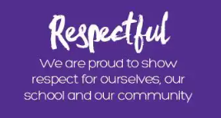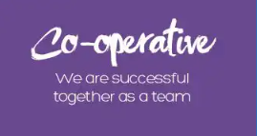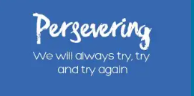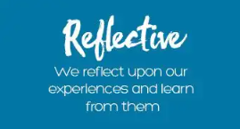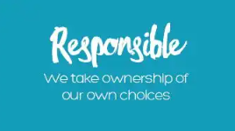
Our Strands of Study:
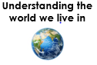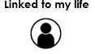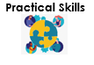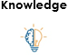

Curriculum Implementation
Purpose of Study at FHC
Understanding the world we live in | Our children often have limited exposure to the wider world as part of their life outside school. Our curriculum aims to deeply connect children with people, places and skills in the world around them as a doorway to confidence in later life. We want them to see a future for themselves that is productive and positive.  We want our children to be global citizens. To be enquiring about new races, cultures and faiths & to be able to articulate their own identity with confidence and skill.  Our curriculum aims to connect children with a wide range of ways of living- letting them see life through the eyes of others so they can make good, informed choices for themselves when the time comes.
Linked to my life | Communication and confidence is key to being a successful member of the global community. Many of our children are not regularly exposed to high quality effective communication as part of their out of school lives. We are committed to ensuring that listening skills, empathy, well-articulated speech and emotional regulation are embedded skills for our children as they leave our school and move out into their independent lives at high school.
Practical Skills  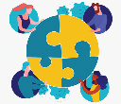 | We want children to develop a wide array of personal skills during their time with us. We want them be able to confidently articulate their strengths and their journey with their challenges. Our culture deeply embeds the value of trying something new and making mistakes and this allows children to develop strategies for problem solving and resilience in the face of adversity.  Our curriculum allows children to try a diverse range of skills during their time with us. This exposure removes the barriers in their developing minds around being ‘a beginner at something’ and allows them to give things a go, irrespective of the quality of the outcome. We celebrate individualism and difference and this allows children to ‘not enjoy/not be skilled at’ something without fear of negative response from their peers. This process is a gateway to confidently trying new things as they move into high school and further education, giving them the key to a future pf their choosing.
Knowledge | Subject progression documents focus on subject specific knowledge children will need to retain and recall, and the skills and strategies needed to manipulate this new information for a specific task, providing a learning pathway which starts at EYFS and ends in Year 6. A clear progression of deepening skills sets, and a greater bank of subject specific knowledge is clearly outlined which build on previous learning
The ‘What? & ‘When?’
Progression of skills documents | Development Matters’ and the ‘National Curriculum’, along with best practice guidance and training, define the key subject specific knowledge we want our children to learn.  We have high expectations for all our pupils, providing them with a well-structured, enhanced curriculum where they have a huge array of opportunities. Subject Progression of skills documents ensures that every step of the learning journey builds on the one before it and therefore builds confidence and capability across a wide array of subjects.  FHC Progression of skills documents:  - Reading  - Writing  - Public Speaking and Drama  - PSHE (Crew)  - PE  - Maths  - Computing  - Craft  - Science  - History  - Geography  - Music  - RE  - MFL  - Forest Schools  Children are supported to take ownership of their learning, and develop these specific skills and attributes for life. Subject progression documents break down key knowledge and skills, concisely and sequentially, that they need in order to be knowledgeable in these areas
Trips and Visitors
As a vehicle for exploring the wider world, every class undertakes 3 trips per year. These are a mixture of (local) Leeds visits and those further afield.

Forest Schools has trips in 4 years groups to support the learning.

As part of the Drama curriculum some classes have visiting performers and others attend the Theatre.

Maths, Literacy, Science, History and Music all have visitors as part of their curriculum.

Through Crew and PSHE we welcome visitors from all faiths and cultures to ensure every child see’s role models they can identify with.

*see matrix of trips and visits in Curriculum guide appendix
‘Daily Challenge’
The daily challenge is a collaborative learning opportunity in which teachers and children learn together. This is skills based and is selected half termly.
The options are limitless as it is not National Curriculum linked. It could be anything from learning to yodel, knitting, counting in a different language right through to refining your single line drawing.
The importance of this task is that children see the adult learn and therefore it is important that the skill is new to all.
5-10 minutes per day is allocated to this collaborative learning project.

Life Skills Curriculum & Social Engagement Activities
Life skills curriculum Yr5&6
Community project
FHC Wombles
School Council

Programs that support our Curriculum
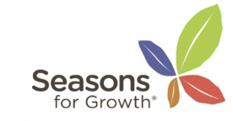
Curriculum Impact
A FHC Learner can…
- Try new things
- Ask for help
- Hold an opinion and share their ideas without needing others to agree with them
- Listen and show respect to others life experience
- Communicate thoughts effectively using appropriate language and detail
- Regulate their emotions and ask for help if they are struggling with this
- Celebrate their unique qualities and skills
- Celebrate the uniqueness of others without feeling threatened by others skills and traits
- Demonstrate integrity In their daily life
- Learn and retain information
- Use their learning to build a picture of the world they live in
- Be inquisitive
- Have aspirations for themselves and work towards personal goals

Sticky Knowledge
At the end of topics children select key information from their learning that they wish to retain and revisit.

Assessment for Learning:

We measure the impact of the curriculum in a number of ways:

- Termly teacher assessment (For Reading, Writing, Maths, Science, PE & PSHE)
- Pre and post units assessment grids (based on Knowledge Organisers for Science, History, Geography & MFL)
- Observations
- Presentations/ celebrations and published work
- Low stake quizzes? (in specific subjects)
- Pupil Voice- Subject Leaders, Governors and SLT led (targeted key questions)
- Staff feedback
- Time Responses (TT RockStars, stamina tasks)
- Progress measures

