

Autism Inclusion Worker Job Description and Personal Specification

December 23

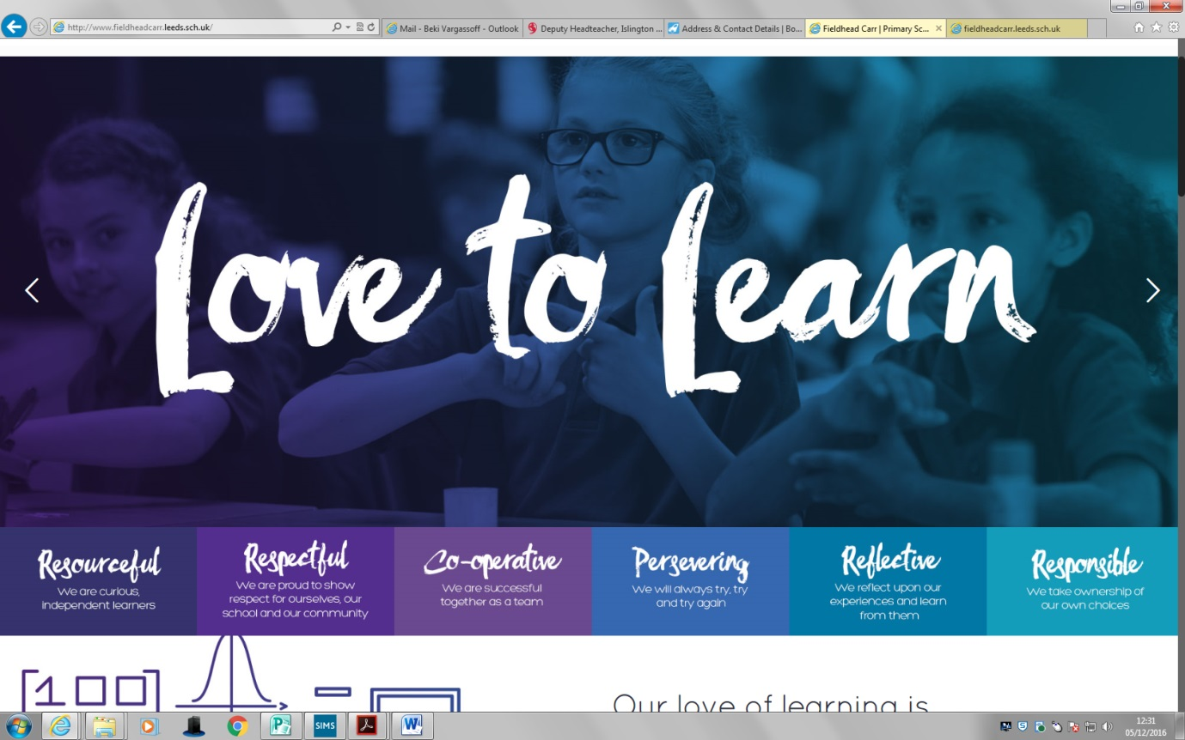

**Deputy Headteacher**

**Autism Inclusion Worker- Job Description**

**Job Title: Behaviour Support Worker @ Fieldhead Carr Primary School**

**Pay Range:** B3 Point 7-11. £24294-25979 (term time only plus 5 training day’s actual salary £20895-£22344)

**Working hours**: 8:15am – 4:00pm Mon-Fri term time plus 5 training days

**Responsible to:** SENDCO/ Pastoral Lead/SLT/Headteacher

**Purpose:**

To work under the instruction and guidance of SENDCO/ Pastoral Lead/Senior Leaders. To support the school in addressing the needs of all pupils with Autism and Communications difficulties. To support the profiling of need for individual children, support teachers in the production of resources to support communication.

To work with staff to develop Autism friendly, individual and whole class approaches through modelling communication and interaction. Establishing productive working relationships with pupils and staff, acting as a role model.

To work 1-1 where needed with children to develop specific skills to help them independently access the school and social environments. Work may be carried out in the classroom or outside the main teaching area. This may involve 1:1 sessions or small group work

This document lays out the fine detail of the job role of Autism Inclusion Worker

**Professional Behaviours**

* AIW to demonstrate professional behaviours appropriate to your role. This includes sustained support and promotion of the school’s philosophy, culture, ethos and climate for learning
* AIW to maintain a calm professional manner when dealing with children, parents and staff
* AIW to maintain levels of professional integrity and confidentiality when dealing with children and families information
* AIW is to follow safeguarding protocols to ensure school practice is consistent for children and families
* AIW will support in planning for staff training and development of policies within the inclusion team, particularly the Behaviour, PSHCE and SEMHS Policy

**Responsibilities**

Support for Pupils:

* Provide one-to-one and small group support to pupils with ASD, tailoring support strategies to individual needs.
* Assist with the development and delivery of Individual Education Plans (IEPs) and monitor pupils' progress.
* Facilitate the social, emotional, and academic well-being of pupils.
* Use visual supports, social stories, and other appropriate strategies to aid pupils' understanding and development.
* Support pupils in managing sensory and anxiety-related challenges.

Support for Teachers:

* Advise and collaborate with teachers on best practices for inclusive teaching strategies.
* Provide guidance on the use of specific resources and adaptations for pupils with ASD.
* Assist in classroom management to create an autism-friendly environment.

Liaison with External Agencies and Parents:

* Collaborate with external professionals such as speech and language therapists, occupational therapists, and educational psychologists to provide holistic support.
* Maintain open communication with parents/carers, providing them with updates on their child's progress and strategies for support at home.

Professional Development:

* Stay updated on the latest research, resources, and interventions related to ASD.
* Attend regular training sessions, workshops, and conferences as required.  
    
  Administrative Tasks:
* Maintain detailed records of interventions, strategies used, and progress made.
* Assist in the preparation of reports as required
* Manage the resourcing and preparation for sessions conducted in Shine 1-1 or in small groups  
    
    
  Qualifications & Experience:
* NVQ Level 3 or equivalent in a relevant field is desirable.
* Prior experience working with children with ASD in an educational setting#
* Experience with Visuals for communication
* Knowledge of the UK primary school curriculum.
* Familiarity with intervention techniques and resources for children with ASD.  
    
    
  Key Competencies & Skills:  
  * Strong interpersonal and communication skills.  
  * Ability to work collaboratively with staff, parents, and external agencies.  
  * Patience, empathy, and resilience.  
  * Ability to adapt quickly to changing situations.  
  * Proficiency in using technology to support learning.

**AUTISM INCLUSION WORKER**

|  |  |  |  |
| --- | --- | --- | --- |
|  | **Ess** | **Des** | **MOA** |
| **KNOWLEDGE/QUALIFICATIONS** |  |  |  |
| Relevant child care and/or educational qualifications |  | * | A/C |
| An awareness of current issues affecting children and young people | * |  | A/I |
| Understanding of health and safety issues and good practice | * |  | A/I |
| Working knowledge of the common assessment framework (CAF) |  | * | A/I |
| Ability to facilitate/deliver a parenting programme/EHP or similar |  | * | A/I |
| GCSE or equivalent Maths and English Grade A - C | * |  | A/C |
| Qualification in Positive Handling | * |  | A/C |
|  |  |  |  |
| **EXPERIENCE** |  |  |  |
| Working with families and young people | **\*** |  | A/I |
| Support the implementation of action plans | * |  | A/I |
|  |  |  |  |
| **SKILLS** |  |  |  |
| Good organisational and personal management skills | * |  | A/I |
| Full driving licence and own transport |  | * | A/I |
| Ability to maintain own caseload under supervisor | * |  | A/I |
| Ability to respond to challenging circumstances | * |  | A/I |
| Effective planning and organisation skills | * |  | A/I |
| Effective behaviour management skills | * |  | A/I |
| Work independently and being a team player | * |  | A/I |
| An ability to develop good working relationships with school staff and other agencies | * |  | A/I |
| Effective time management | * |  | A/I |
| Ability to work with class teachers and support them with inclusion of children with additional needs | * |  | A/I |
| The ability to prioritise workload and have a flexible approach to working | * |  | A/I |
| The ability to meet deadlines | * |  | A/I |
| Good ICT skills | * |  | A/I |
| **BEHAVIOUR AND OTHER RELATED CHARACTERISTICS** |  |  |  |
| Commitment to self and team development | * |  | A/I |
| Commitment to inclusive practices and achieving positive outcomes for children and their families | * |  | A/I |
| Work in ways that promote equality of opportunity, participation, diversity  and responsibility | * |  | A/I |
| A commitment to abide by and promote the school’s Equal  Opportunities, Health and Safety and Child Protection Policies | * |  | A/I |
| A professional responsibility to promote and safeguard the welfare of  children and young people | * |  | A/I |
| The post holder will require an enhanced DBS | * |  | C |

Key: MOD=Method of Assessment, Ess=Essential, Des=Desirable, A=Application, I=Interview and assessment, R=Reference, C=Certificate