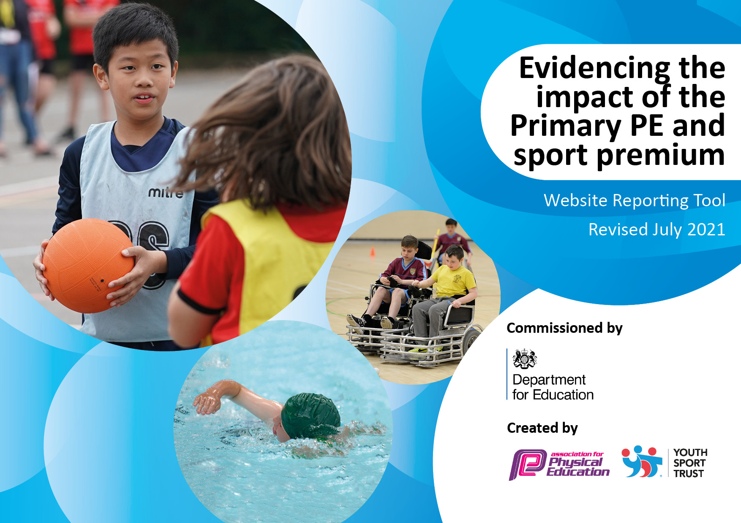

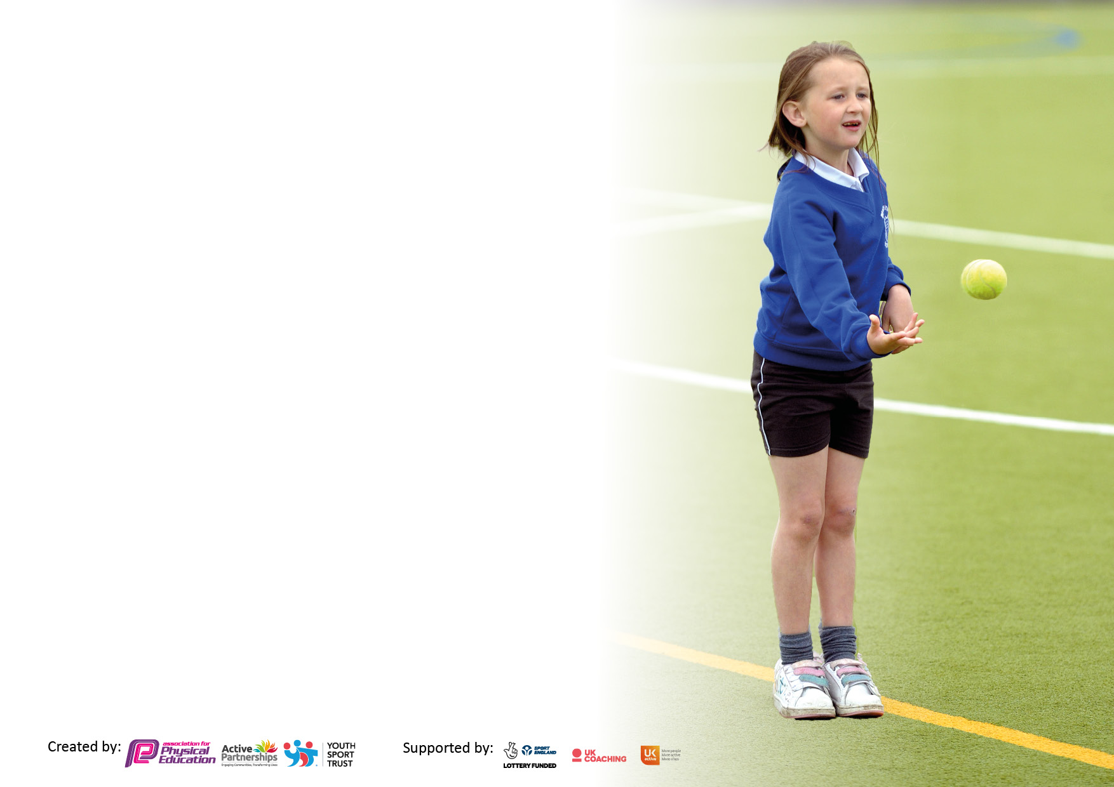

It is important that your grant is used effectively and based on school need. The [Education Inspection Framework](https://assets.publishing.service.gov.uk/government/uploads/system/uploads/attachment_data/file/843108/School_inspection_handbook_-_section_5.pdf) makes clear there will be a focus on **‘whether leaders and those responsible for governors all understand their respective roles and perform these in a way that enhances the effectiveness of the school’**.

Under the [Quality of Education](https://assets.publishing.service.gov.uk/government/uploads/system/uploads/attachment_data/file/843108/School_inspection_handbook_-_section_5.pdf) Ofsted inspectors consider:

**Intent** - Curriculum design, coverage and appropriateness

**Implementation** - Curriculum delivery, Teaching (pedagogy) and Assessment

**Impact** - Attainment and progress

To assist schools with common transferable language this template has been developed to utilise the same three headings which should make your plans easily transferable between working documents.

Schools must use the funding to make **additional and sustainable** improvements to the quality of Physical Education, School Sport and Physical Activity (PESSPA) they offer. This means that you should use the Primary PE and sport premium to:

* Develop or add to the PESSPA activities that your school already offer
* Build capacity and capability within the school to ensure that improvements made now will benefit pupils joining the school in future years
* The Primary PE and sport premium should not be used to fund capital spend projects; the school’s budget should fund these.

Pleasevisit[gov.uk](https://www.gov.uk/guidance/pe-and-sport-premium-for-primary-schools)fortherevisedDfEguidanceincludingthe5keyindicatorsacrosswhichschoolsshoulddemonstrate animprovement.Thisdocumentwillhelpyoutoreviewyourprovisionandtoreportyourspend.DfEencouragesschools to use this template as an effective way of meeting the reporting requirements of the Primary PE and sport premium.

We recommend you start by reflecting on the impact of current provision and reviewing the previous spend.

Schools are required to [publish details](https://www.gov.uk/guidance/what-maintained-schools-must-publish-online#pe-and-sport-premium-for-primary-schools) of how they spend this funding, including any under-spend from 2019/2020, as well as on the impact it has on pupils’ PE and sport participation and attainment. **All funding must be spent by 31st July 2022.**

We recommend regularly updating the table and publishing it on your website throughout the year. This evidences your ongoing self-evaluation of how you are using the funding to secure maximum, sustainable impact. Final copy must be posted on your website by the end of the academic year and no later than the 31st July 2021. To see an example of how to complete the table please click [HERE](http://www.afpe.org.uk/physical-education/wp-content/uploads/afPE-Example-Template-Indicator-2018-Final.pdf).



**Details with regard to funding**

Please complete the table below.

|  |  |
| --- | --- |
| Total amount carried over from 2019/20 | £0 |
| Total amount allocated for 2020/21 | £18,045 |
| How much (if any) do you intend to carry over from this total fund into 2021/22? | £0 |
| Total amount allocated for 2021/22 | £18,045 |
| Total amount of funding for 2021/22. To be spent and reported on by 31st July 2022. | £18,045 |

**Swimming Data**

Please report on your Swimming Data below.

|  |  |
| --- | --- |
| Meeting national curriculum requirements for swimming and water safety.  N.B. Complete this section to your best ability. For example you might have practised safe self-rescue techniques on dry land which you can then transfer to the pool when school swimming restarts.  **Due to exceptional circumstances priority should be given to ensuring that pupils can perform safe self rescue even if they do not fully meet the first two requirements of the NC programme of study** |  |
| What percentage of your current Year 6 cohort swim competently, confidently and proficiently over a distance of at least 25 metres?  **N.B.** Even though your pupils may swim in another year please report on their attainment on leaving primary school at the end of the summer term 2020.  Please see note above | 66% |
| What percentage of your current Year 6 cohort use a range of strokes effectively [for example, front crawl, backstroke and breaststroke]?  Please see note above | 78% |
| **What percentage of your current Year 6 cohort perform safe self-rescue in different water-based situations?** | 89% |
| Schools can choose to use the Primary PE and sport premium to provide additional provision for swimming but this must be for activity **over and above** the national curriculum requirements. Have you used it in this way? | No |

**Action Plan and Budget Tracking**

Capture your intended annual spend against the 5 key indicators. Clarify the success criteria and evidence of impact that you intend to measure to evaluate for pupils today and for the future.

|  |  |  |  |  |
| --- | --- | --- | --- | --- |
| **Academic Year:** 2020/21 | **Total fund allocated: £13,800** | **Date Updated: 27.4.2022** | |  |
| **Key indicator 1:** The engagement of all pupils in regular physical activity – Chief Medical Officers guidelines recommend that primary school pupils undertake at least 30 minutes of physical activity a day in school | | | | Percentage of total allocation: |
| 76% |
| **Intent** | **Implementation** | | **Impact** |  |
| Your school focus should be clear what you want the pupils to know and be able to do and about  what they need to learn and to  consolidate through practice: | Make sure your actions to achieve are linked to your intentions: | Funding allocated: | Evidence of impact: what do pupils now know and what can they now do? What has changed?: | Sustainability and suggested next steps: |
| * Clubs on offer after school (3 days a week) to children of all abilities and ages. * Lunch time playground rota introduced to give children an equal chance and opportunity to use different sporting areas within school * Research physical activity programmes and interventions including Active Learning and 10 minute activity breaks. | * Full time member of staff employed to offer a variety of after school sports clubs * Football nets purchased to add additional areas for children to play during break and lunchtimes * New lunchtime equipment purchased to give children of all ages the opportunity to play different sports and activities * To explore the ‘Daily Mile’ as possible physical activity intervention which could be implemented throughout the school. * Sports Leaders to support and guide children to get involved in a variety of physical activity during break and lunchtimes | £13,800 | * Increased participation from both male and female children of all ages * Decrease of behavioural incidents at break and lunch times * Children more engaged and focused * Daily Mile introduced. Teachers reporting that children are more focused and alert during lessons | * Parent and children questionnaire to find out enjoyment levels and areas for improvement * Children questionnaire to find out what areas of the playground they want to improve things they are currently enjoying * Parent and children ideas for additional or change in after school sport provision. |
| **Key indicator 2:** The profile of PESSPA being raised across the school as a tool for whole school improvement | | | | Percentage of total allocation: |
| 11% |
| **Intent** | **Implementation** | | **Impact** |  |
| Your school focus should be clear what you want the pupils to know and be able to do and about  what they need to learn and to  consolidate through practice: | Make sure your actions to achieve are linked to your intentions: | Funding allocated: | Evidence of impact: what do pupils now know and what can they now do? What has changed?: | Sustainability and suggested next steps: |
| * Further embed a culture of participation in physical activity and school sport. * Richer variety of extra-curricular sports provision offered to pupils | * Updated PE board to include: photographs of children participating in PE and other sport; upcoming sports events listed for children to represent the school and current term PE focus. * Teachers promote PE wearing sports kit to teach all PE lessons * Sports coaches from different sports which the children would otherwise have limited access brought into school for taster sessions and/or extra-curricular sessions. * A variety of after-school sports clubs delivered by external coaches. * Sports week that promoted physical activity, healthy lifestyles and variation of different sports and games. | £2,000 | * PE / Sport is gaining a higher profile across the school with a greater number of children participating in lunch time and after school clubs. Strong uptake across all year groups. * Decrease in behavioural incidents during PE lessons * Teachers recognising children’s positive attitude towards PE as a subject | * Regular reminders to staff for updates and photos for the board * Teachers to incorporate the importance of PE into classroom lessons * Success to be celebrated in assemblies – including children’s achievements outside of school. |

|  |  |  |  |  |
| --- | --- | --- | --- | --- |
| **Key indicator 3:** Increased confidence, knowledge and skills of all staff in teaching PE and sport | | | | Percentage of total allocation: |
| 0% |
| **Intent** | **Implementation** | | **Impact** |  |
| Your school focus should be clear | Make sure your actions to | Funding | Evidence of impact: what do | Sustainability and suggested |
| what you want the pupils to know | achieve are linked to your | allocated: | pupils now know and what | next steps: |
| and be able to do and about | intentions: |  | can they now do? What has |  |
| what they need to learn and to |  |  | changed?: |  |
| consolidate through practice: |  |  |  |  |
| Teaching and learning in PE is consistently good    1. Monitoring of teaching and learning in PE    2. Pupils achieve the expected outcomes for National Curriculum PE    3. The PE curriculum is progressive, broad and balanced    Teachers are confident, knowledgeable and skilled in delivering HQPE | * Employment of full time member of staff to support the delivery of PE across KS1 and KS2. * PE Subject Leader to meet with a broad range of pupils to discuss their PE lessons and understanding of skills though pupil voice. To be completed every term. * PE resources audited and prepared in advance of PE lessons. * SL to carry out observations / learning walks of PE lessons – To do in the Summer Term after CT’s comfortable teaching PE * SL to monitor PE curriculum coverage * Devise a curriculum map for all staff to follow. * Audit and purchase of equipment. | £1000.00 | * 80% lessons observed, and outcomes used to plan further training for staff      * Pupils are developing leadership, coaching and officiating skills, for example * Pupils are confident to try new activities as well as enhancing skills in a diverse range of environments * Pupils behaviour is good in PE lessons and pupils cooperate in collaborative and competitive situations * All year groups across the school using LTP for PE * All staff are following the curriculum map * Activities are taught in depth by teachers | * Staff survey to be completed to provide insight into their thoughts into the quality of PE delivered and their confidence in delivery of PE * Establish and embed an assessment framework for PE including a measurement of how many pupils are achieving the expected outcomes at the end of key stages * -Establish framework using the curriculum map for teachers to evidence PE curriculum coverage to be for transition between year groups * Revise PE curriculum (if necessary) once questionnaires are back in. |
| **Key indicator 4:** Broader experience of a range of sports and activities offered to all pupils | | | | Percentage of total allocation: |
|  |
| **Intent** | **Implementation** | | **Impact** |  |
| Your school focus should be clear | Make sure your actions to | Funding | Evidence of impact: what do | Sustainability and suggested |
| what you want the pupils to know | achieve are linked to your | allocated: | pupils now know and what | next steps: |
| and be able to do and about | intentions: |  | can they now do? What has |  |
| what they need to learn and to |  |  | changed?: |  |
| consolidate through practice: |  |  |  |  |
| Additional achievements:   * Parents, volunteers, sports coaches and local partners provide wider opportunities for pupils. * Work in partnership with other schools for mutual benefits of pupils and staff * Develop extracurricular programme to include a wider range of activities for all year groups that appeal and meet the needs of all pupils formulated through consultation with pupils * Ensure maximum uptake of our extra-curricular clubs to engage as many pupils in clubs as possible * Develop outdoor learning area to broaden experience of pupils | * Monitor pupil participation and identify pupils who are not regularly taking part. Have a conversation with these pupils to ascertain the barriers to participation and identify the most popular times for clubs to run * Set up a Sports Council / Sport Organisers Crew * Explore the use of coaches and parents to support the delivery of the programme * Use Sports Council to consult re developing outdoor provision. * Explore links with local clubs and parents to offer taster sessions in school * Full time member of staff employed to offer a variety of after school sports clubs | £ | * 3 new clubs now running with an uptake of 10% pupils (5% of which have never taken part before)      * Sports leaders being used during break and lunchtimes      * Pupils more engaged at playtimes and lunchtimes and there have been less incidents relating to poor behaviour reported | * Develop community links and a community notice board within the school      * Explore ways that Sports leaders can contribute to whole school decision making      * Develop opportunities for pupils at play and lunchtimes      * Develop Play Leader programme and implement |

|  |  |  |  |  |
| --- | --- | --- | --- | --- |
| **Key indicator 5:** Increased participation in competitive sport | | | | Percentage of total allocation: |
| 13% |
| **Intent** | **Implementation** | | **Impact** |  |
| Your school focus should be clear | Make sure your actions to | Funding | Evidence of impact: what do | Sustainability and suggested |
| what you want the pupils to know | achieve are linked to your | allocated: | pupils now know and what | next steps: |
| and be able to do and about | intentions: |  | can they now do? What has |  |
| what they need to learn and to |  |  | changed?: |  |
| consolidate through practice: |  |  |  |  |
| * Develop the competition programme to include a wider range of competitions and activities for all year groups that appeal and meet the needs of all pupils formulated through consultation with pupils. This will include personal best, intra and inter competitions * New football nets purchased allowing for FHC to host more tournaments against local schools | * Link with other local schools to compete in different sports * Participate in a range of sports competitions across Leeds. * After school clubs to reflect the competition calendar | £300 for transport costs  £945 equipment | * Extra-curricular provision broadened and uptake evident. * Growing opportunities for children entering competitions to represent the school. * Links made with 5/6 local schools to begin a football tournament starting in Autumn 2. | * Interschool sports competitions to be launched within school * Continue entering further teams into out of school competition. |

|  |  |
| --- | --- |
| Signed off by | |
| Head Teacher: |  |
| Date: |  |
| Subject Leader: | Stevie Stockton and Mr McManus |
| Date: | 27/04/2022 |
| Governor: |  |
| Date: |  |