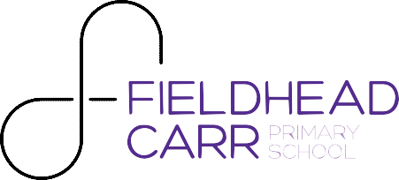

Monday 12th September 2016

Dear Parents/Carers,

Welcome back to a brand new school year at Fieldhead Carr Community Primary School. I hope you had a wonderful summer. It is fantastic to see all the children back, and to see them looking so smart. We are delighted that so many of them are proudly displaying our new logo – so thank you for your support with this.

Over the summer we have been busy preparing for the new academic year, I hope you have all had a chance to admire the new signage around the outside of the building and that the children have been talking to you about our ‘Fieldhead Factors’(code of conduct) launch on Thursday which featured some familiar faces from ITV’s ‘The X-Factor’. We are also now on Twitter, why not follow us @FieldheadCarrPS?

To update you on some of the new school systems and to allow this academic year to run as smoothly as possible, I have enclosed a pack of documentation for you to read. Some of these are for your reference and some require you to fill in/sign and send back to your child’s class teacher or the main school office. I have indicated which are which below.

This pack contains:
- The Parent Handbook – an information guide with everything you need to know about the day to day operation of our school. This is for you to keep and refer to over the course of the year.
- Our Home School Agreement – Please read and sign with your child and return it to your child’s class teacher, who will also sign it on behalf of the school.
- Data collection form – please complete one of these per child that attends our school and send it back to the main school office. This allows us to update our records and ensure we have the most recent contact information for you.
If you have any questions regarding any of these documents, please feel free to contact the main office or your child’s class teacher.
Thank you in advance for your support with this.
I look forward to meeting you all over the course of the next few weeks.
Yours Sincerely,

Beki Vargassoff
Headteacher

Love to Learn
0113 2930226
www.fieldheadcarr.leeds.sch.uk hello@fieldheadcarr.leeds.sch.uk
Fieldhead Carr Primary School Naburn Approach
Leeds LS14 2EG

